Chapter 1: Setting the Context

Introduction: Why ESG Matters Now More Than Ever
Today, businesses face significant challenges: climate change, dwindling resources, and social inequality. These aren’t just “nice to fix” issues—they represent major risks for any organization. Companies are now expected to act responsibly, care for the planet, and respect people. That’s why Environmental, Social, and Governance (ESG) practices have become essential to business success.
Strong ESG practices can make your business more resilient and competitive. Stakeholders—from investors to customers—demand transparency. They trust companies that demonstrate they care. And businesses that embrace ESG often outperform their competitors.
In this book, we’ll help you understand ESG and integrate it into your business strategy. We'll guide you through practical steps—starting with assessing where you are now, setting goals, and creating an action plan. You’ll learn how to track your progress and share your successes. By the end, you’ll have a clear path forward—helping your business thrive in a world where ESG is no longer optional.

Key Points Summary: Why ESG Matters Today
- Challenges: Climate change, dwindling resources, social inequality.
- Business Impact: ESG is not just an option—it is critical for risk management and staying competitive.
- Stakeholder Demand: Investors, customers, and regulators are expecting responsible actions from businesses.

.

How This Guide is Arranged
This guide is designed to take you through a systematic process for developing, implementing, and sustaining an effective ESG strategy. Each chapter builds upon the previous one, providing you with the insights and tools needed to succeed:
- Chapter 1: Setting the Context
  - Introduction to ESG: Why it matters and how to gain organisational buy-in.
- Chapter 2: Current State Assessment and Gap Analysis
  - How to evaluate your current ESG performance, engage stakeholders, and conduct a gap analysis.
- Chapter 3: Materiality Assessment and Stakeholder Engagement
  - Conducting a materiality assessment and ensuring your ESG strategy addresses the most critical issues.
- Chapter 4: Developing Your ESG Strategy
  - Setting realistic ESG goals, aligning them with corporate strategy, and creating a roadmap.
- Chapter 5: Implementation and Oversight
  - Practical guidance on executing the strategy, tracking KPIs, and managing challenges.
- Chapter 6: ESG Reporting and Communication
  - Understanding ESG reporting frameworks and communicating progress to stakeholders.
- Appendix: Tools and Templates
  - Templates for KPIs, materiality matrices, and checklists to help execute each step.

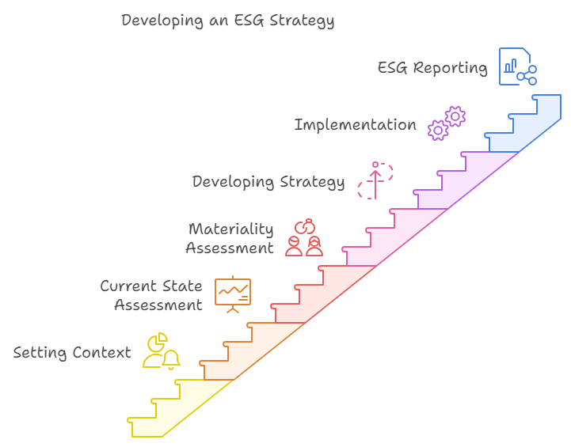

1.1 What is ESG Strategy?
A Brief Background
In recent decades, the significance of ESG (Environmental, Social, and Governance) has steadily increased. Traditionally, businesses were primarily focused on maximising profits and complying with regulations. However, the dialogue has expanded in response to growing societal concerns about environmental sustainability and social equity.
During the 1970s and 1980s, the concept of corporate social responsibility (CSR) emerged, encouraging companies to consider their impact on society and the environment, not merely their financial performance. This has since evolved into today’s emphasis on ESG, which encompasses a company’s entire operational framework.
Key Points Summary: The Three Pillars of ESG
- Environmental: Focus on reducing energy consumption, carbon emissions, and waste management.
- Social: Emphasizes workplace diversity, employee well-being, and community relations.
- Governance: Involves transparency, ethical business practices, and board diversity

Adopting an ESG strategy involves integrating environmental, social, and governance factors into business operations to create long-term value, manage risks, and demonstrate a commitment to sustainability and societal well-being.
Environmental: This refers to a company’s impact on the planet. Key considerations include energy consumption, carbon emissions, waste management, water usage, and biodiversity conservation.

Social: The social aspect focuses on people both within and outside the organisation. It includes workplace diversity, employee well-being, supply chain labour practices, and community engagement.
Think of ESG like this
ESG is like a three-legged stool. The environmental leg ensures you minimize harm to the planet, the social leg makes sure you’re good to people, and the governance leg keeps the company ethical and transparent. Without all three legs balanced, the stool—and the business—won’t stand strong.

Governance: Governance pertains to how the company is managed. It involves transparency, ethical business conduct, board diversity, executive remuneration, and regulatory compliance.

Developing a robust ESG strategy allows companies to demonstrate their commitment to ethical practices, laying the groundwork for long-term success. Embracing ESG factors helps protect businesses from potential legal consequences and reputational damage, while also creating opportunities for innovation and growth.

1.2 Why Businesses Need ESG Now
The Growing Importance of ESG
Today, regulators, investors and consumers seek greater transparency regarding a business’s environmental and social impacts. Globally, over $35 trillion in assets are managed with a focus on ESG criteria, reflecting the growing importance of sustainability in investment decisions.
Key Points Summary: Why ESG is Crucial for Business Today
- Regulatory Drivers: Stricter regulations such as the EU Green Deal.
- Investor Expectations: Major investors like BlackRock prioritize companies demonstrating strong ESG practices.
- Consumer Preferences: 70% of consumers prefer sustainable brands, influencing profitability.

To illustrate why ESG matters, let us break it down into three key drivers:
- Regulatory Drivers: Governments are implementing stricter regulations to safeguard the environment. For example, the European Union’s Green Deal targets climate neutrality by 2050, introducing more rigorous emissions and environmental reporting requirements. Companies that do not comply with these regulations face substantial penalties and reputational damage. This was evident in the Volkswagen emissions scandal (you will learn more about it in the next section), where the company incurred billions in fines and suffered serious harm to its public image due to the revelation of emissions test manipulation.
- Investor Expectations: ESG performance has become increasingly important for investors. Major institutional investors, including pension funds, now prioritise companies that demonstrate strong ESG practices. BlackRock, for example, has publicly stated that it will divest from companies that do not align with its sustainability goals—reflecting a significant shift in investment strategy.

- Consumer Preferences: Consumers are increasingly favouring sustainable brands. Around 70% of consumers report they are willing to pay more for sustainable products. Unilever found that its sustainable brands grew faster than the rest of its portfolio, demonstrating that sustainability can also enhance profitability.
Relatable Example: Why Consumer Preferences Matter
Imagine a customer choosing between two brands of bottled water—one clearly demonstrates its environmental efforts, while the other does not. Most people will opt for the one with visible sustainability, even if it costs a little more. This simple decision reflects the power of ESG in attracting and retaining customers.

1.2.1 Historical Incidents Highlighting ESG Importance

- Rana Plaza Collapse (2013): The Rana Plaza disaster in Bangladesh, where a garment factory building collapsed, killing over 1,100 workers, brought global attention to labour practices and safety in the supply chain. This tragedy underscored the need for companies to prioritise worker safety and ethical sourcing. Following the incident, many brands faced backlash for inadequate oversight in their supply chains, leading to increased pressure for stronger labour rights and greater transparency. As a result, the Accord on Fire and Building Safety in Bangladesh was established, highlighting the urgent need for improved governance in supply chain practices.
Supply Chain Oversight - A Relatable Example
Running a supply chain without proper oversight is like running a restaurant without knowing where your ingredients come from. If there’s a problem, customers will blame you, not the supplier.

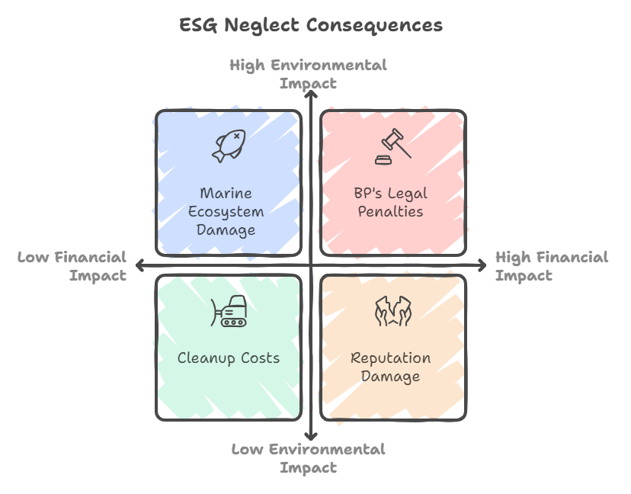
- BP Deepwater Horizon Oil Spill (2010): The Deepwater Horizon oil spill is one of the most significant environmental disasters in history. It resulted in the release of approximately 4.9 million barrels of oil into the Gulf of Mexico, causing severe damage to marine and coastal ecosystems. The incident underscored the critical need for effective environmental governance and risk management. BP faced extensive legal penalties, cleanup costs exceeding $60 billion, and long-term harm to its reputation. This event serves as a stark reminder of the potential financial and environmental risks associated with neglecting ESG responsibilities.

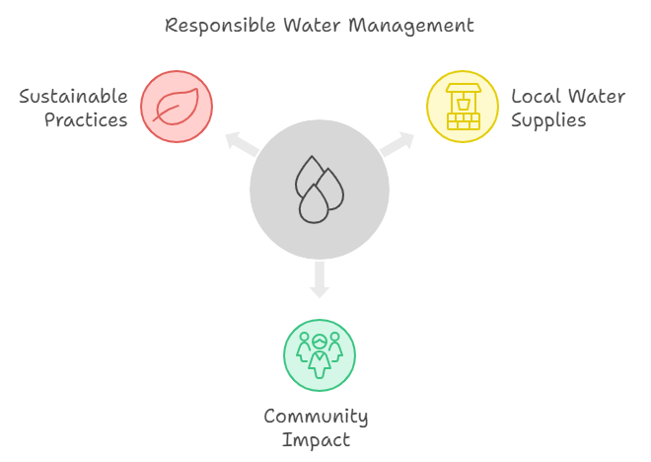
- Nestlé and Water Resources (2000s): Nestlé has faced criticism over its bottled water operations, particularly in regions experiencing water scarcity. The company has been accused of depleting local water supplies in California and Michigan, leading to public outcry and protests. These events have underscored the importance of responsible water management as part of ESG practices. Companies are increasingly aware of how their resource extraction activities can affect communities and ecosystems, prompting a shift towards more sustainable water management.

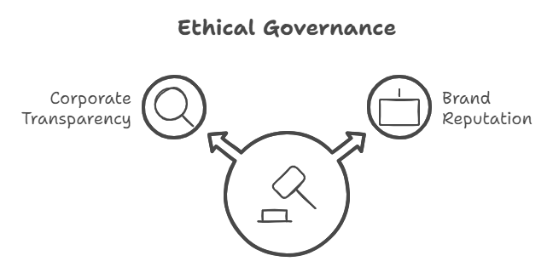
- Volkswagen Emissions Scandal (2015): Volkswagen was caught cheating on their emissions tests. It was like taking an exam but using a hidden calculator when you were supposed to work everything out by hand. They tried to appear more environmentally friendly than they actually were. When the truth came out, Volkswagen ended up paying billions in fines and lost a great deal of trust. It serves as a powerful reminder that honesty and transparency are vital components of any ESG strategy—cutting corners can be extremely costly.

Without a solid ESG strategy, companies risk falling behind those quicker to adapt to these expectations. These historical incidents demonstrate that the fallout from failing to address ESG issues can be severe. Integrating ESG into business practices is no longer optional; it is essential for survival and future success.

1.3 The First Step: Gaining Organizational Buy-In
The first—and most crucial—step in creating an ESG strategy is securing organisational buy-in at all levels, particularly from leadership. Without strong support from the top, ESG initiatives risk being underfunded, deprioritised, or viewed as separate from core business objectives. For an ESG strategy to succeed, it must be led by leadership, embedded in the corporate mission, and integrated into every aspect of the business.
Companies sometimes pursue ESG in response to regulatory requirements imposed by a parent company or external regulators. Even in these cases, it is essential to communicate to leadership that the ESG strategy should not be treated merely as a compliance exercise, but rather as a value driver for long-term growth, resilience, and competitive advantage.
Key Points Summary
Gaining Organizational Buy-In
- Leadership Support: Without it, ESG initiatives will fail.
- Align ESG with Business Goals: ESG should not be a separate project but part of the company’s core strategy.
- Value Proposition: ESG drives growth, resilience, and long-term competitive advantage.

1.3.1 Forming an Internal ESG Development Team
One option is to develop the ESG strategy internally by forming a cross-functional team with representation from key departments. This internal team will create a strategy that reflects the organisation’s unique needs and culture, while drawing on expertise from across departments.
Steps for Forming an Internal ESG Development Team:
- Identify Key Departments for Representation:
It is essential to involve critical departments that will directly or indirectly influence ESG initiatives. These include:

- Operations – to understand environmental impacts and energy use.
- Finance – to evaluate financial implications, budget requirements, and potential cost-saving opportunities related to ESG.
- HR – to ensure employee well-being, and that diversity and inclusion policies align with ESG goals.
- Legal – to navigate compliance, ensure adherence to regulations, and mitigate risk.
- Procurement – to assess and ensure sustainable supply chain practices, such as ethical sourcing and minimising environmental impact.
- Appoint an ESG Champion or Leader:
This individual will lead the team and ensure ESG remains a priority. The ESG champion should be capable of driving decisions and aligning ESG with the company’s overall corporate strategy.
- Define Team Objectives and Deliverables:
The team should clearly outline what it intends to achieve, such as identifying ESG priorities, conducting initial assessments, and developing a timeline for strategic implementation.
- Engage with Broader Teams:
Encourage collaboration beyond the core team by involving other departments or establishing a wider network of ESG advocates across different business units. This helps embed ESG values throughout the company culture.

1.3.2 Hiring External Consultants for ESG Strategy Development
Hiring external consultants may be the best option if the organisation lacks internal expertise or capacity. They bring specialised knowledge of ESG trends, regulatory requirements, and best practices, supporting companies in designing a robust, scalable strategy.

Critical steps to hiring external consultants include:

CHECKLIST

Steps to Create an Effective ESG Team:
- Identify Key Departments: Include representatives from operations, finance, HR, legal, and procurement.
- Appoint an ESG Champion: This person leads the team and aligns ESG initiatives with overall business strategy.
- Define Team Objectives: Outline clear goals, timelines, and deliverables for strategic ESG implementation.
Action Steps: Forming an ESG Team

- Identify the Right Consulting Firm:
Industry Expertise: Seek consultants with experience in ESG issues specific to your industry. This helps ensure that their recommendations are both relevant and actionable.
Customisation: Their advice should be tailored to your company’s unique challenges, rather than adopting a "one-size-fits-all" approach.
Proven Results: Review their track record. Choose firms that have successfully delivered measurable outcomes for other clients.

- Define Scope and Expectations:
- Be clear about what you want the consultant to achieve, such as a baseline assessment, development of KPIs, and an implementation roadmap.
- Develop a detailed Scope of Work (SOW) that includes project timelines, deliverables, and key milestones to keep everyone on track.
- Integrate External Knowledge Internally:
- Ensure that external consultants collaborate closely with your internal team. This cooperation enables your team to learn from the experts, helping to build internal capability for ongoing ESG initiatives after the consultancy concludes.
Steps for Establishing an ESG Task Force:
- Select Task Force Members:
The task force should include senior representatives from key departments (e.g. operations, finance, legal, HR). This helps ensure that each department has a stake in executing the ESG strategy and that no aspect of the business is overlooked.
- Define Responsibilities:
The ESG Task Force is responsible for:
  - Monitoring progress against the ESG roadmap.
  - Identifying risks and challenges to implementation.
  - Reporting back to the CEO and senior leadership on key milestones and potential adjustments to the strategy.
  - Ensuring compliance with regulations and meeting the company’s ESG commitments.
- Track Performance:
Use Key Performance Indicators (KPIs) to monitor progress. These metrics might include carbon emissions, waste reduction, employee diversity, or ethical governance. Tracking these indicators helps maintain focus and ensures that the strategy delivers tangible results.
- Regular Communication:
Communicate progress regularly with leadership. Providing consistent updates to senior executives helps address challenges promptly and maintain momentum. Reporting can also be extended to stakeholders, where transparency is critical to building trust.
- Adjust Strategy as Needed:
ESG expectations are constantly evolving—driven by changes in regulations, market trends, and stakeholder demands. The ESG Task Force should periodically assess whether the strategy requires adjustment to remain practical and relevant. This flexibility ensures the company remains proactive rather than reactive.


Presenting the Business Case for ESG
To achieve leadership, buy-in, presenting the business case for ESG is essential. This means clearly articulating how ESG initiatives:

- Improve operational efficiency (e.g., reducing energy use lowers costs).
- Mitigate risks (e.g., compliance with regulations avoids fines, avoiding reputational damage).
- Enhance brand reputation and help attract and retain talent, customers, and investors who value sustainability.

Leadership needs to understand that ESG is not just about fulfilling obligations—it is about driving long-term growth and building a resilient, future-ready organisation.
With a clear understanding of why ESG matters, and the importance of securing organisational support, it is time to assess your company’s current situation. Chapter 2 will guide you through conducting a Current State Assessment and performing a Gap Analysis—crucial steps in understanding where you are now and where improvements are needed.
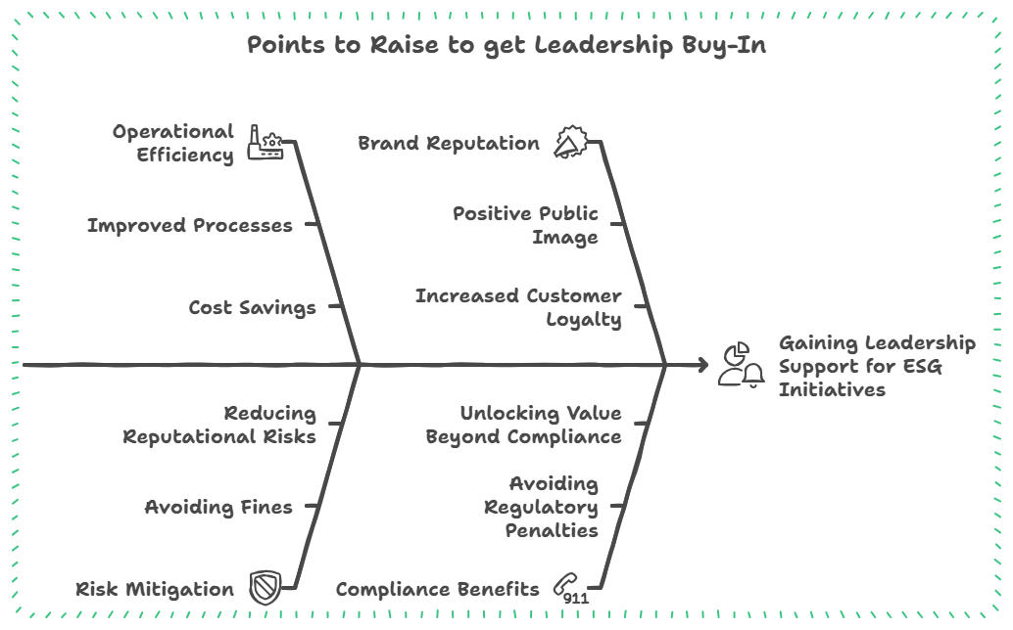

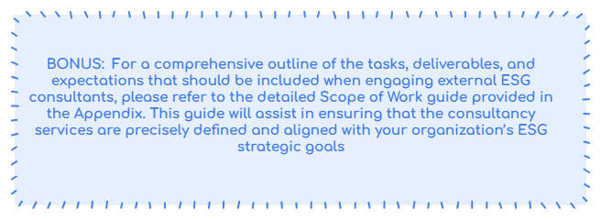

Appendix: Detailed Scope of Work Guide for Hiring ESG Consultants
This detailed Scope of Work (SOW) template is designed to guide your organisation through the process of effectively engaging external ESG consultants. It ensures a comprehensive approach, covering assessment, strategy development, implementation planning, and reporting.

1. Project Objectives:
- Clearly define the primary ESG goals the consultant is expected to achieve.
- Highlight the strategic relevance of these goals in relation to broader business objectives.

2. Comprehensive Assessment:
- Conduct a thorough baseline assessment of existing ESG practices and performance metrics.
- Perform a detailed regulatory compliance review tailored to the specific requirements of your industry and geographic location.
- Identify gaps in current ESG initiatives relative to industry benchmarks and best practices.

3. Strategy Formulation:
- Develop a bespoke ESG strategy encompassing environmental, social, and governance dimensions, tailored to your company’s scale, sector, and strategic vision.
- Formulate actionable initiatives for each identified gap, with clear guidance on integration into corporate operations.

4. Implementation Roadmap:
- Create a detailed implementation plan specifying phases, key actions, responsible parties, resource allocation, and risk mitigation strategies.
- Outline necessary organisational changes, including the creation of new roles or adjustments to existing positions to support ESG initiatives.
- Develop a comprehensive training programme for all levels of staff, focused on ESG awareness, responsibilities, and best practices.

5. Performance Metrics and Reporting:
- Define specific, measurable KPIs to track progress against each component of the ESG strategy.
- Establish a performance monitoring system, including data collection tools and reporting protocols.
- Prepare internal and external ESG reporting templates aligned with global standards such as GRI, SASB, and TCFD.

6. Deliverables:
- Provide a comprehensive ESG strategy document detailing findings, recommendations, and the implementation roadmap.
- Deliver a series of progress reports at predetermined milestones throughout the consultancy period.
- Conclude with a final report summarising achievements, lessons learned, and recommendations for continuous improvement.

7. Timeline:
- Detail the expected start date and overall project duration, with a timeline outlining key phases and critical milestones.
- Include specific deadlines for deliverables and periodic review meetings to assess progress and adjust plans as required.

8. Budget and Payment Terms:
- Outline the total costs associated with the consultancy, including a breakdown for the assessment, strategy development, and reporting phases.
- Specify payment terms linked to milestone achievements or deliverable completion to ensure accountability and timely execution.

9. Consultant Qualifications and Selection Criteria:
- Detail the required qualifications and experience of the consultancy team, with emphasis on expertise in ESG challenges relevant to your industry.
- Describe the selection process, including criteria for evaluating proposals and consultant capabilities.

10. Confidentiality and Data Protection:
- Include clauses on confidentiality to protect sensitive company information shared during the consultancy engagement.
- Specify data protection measures that comply with relevant legal standards, ensuring the security of any personal or proprietary data involved in the project.
References:
- BlackRock. (2020). Larry Fink's 2020 Letter to CEOs: A Sense of Purpose.
- Global Sustainable Investment Alliance. (2020). Global Sustainable Investment Review 2020.
- Hotten, R. (2015). Volkswagen: The Scandal Explained. BBC News.
- Nielsen. (2015). The Sustainability Imperative: New Insights on Consumer Expectations.
- Unilever. (2020). Unilever’s Sustainable Living Brands Growth.

Chapter 2: Laying the Foundation

2.1 Understanding your Current State Assessment
Before crafting a transformative ESG strategy, you must first ask: Where are we now? A Current State Assessment (CSA) is a diagnostic tool that offers a detailed snapshot of your organisation’s ESG landscape. It highlights strengths, exposes vulnerabilities, and serves as the foundation of a purpose-led, data-driven strategy. Understanding your baseline ensures that your ESG efforts align with operational realities and meet stakeholder expectations.
Example: Why CSA Matters
Case Study: A Cement Manufacturer
A global cement manufacturer discovered during its Corporate Sustainability Assessment (CSA) that 70% of its carbon emissions originated from clinker production. By identifying this emissions hotspot, the company prioritised investment in alternative materials, achieving a 15% reduction in CO₂ emissions over three years.

Key Points Summary: Why Conduct a Current State Assessment
- Define Your Starting Point: Understand your company's current ESG strengths and weaknesses.
- Highlight Vulnerabilities: Identify areas that need urgent attention to prevent risks.
- Foundation for Strategy: A well-conducted CSA is the backbone of your entire ESG strategy.

2.2 Steps to Conduct a Comprehensive Current State Assessment
Step 1: Setting Boundaries and Defining Scope
The first crucial step in your CSA is to define its scope. Determining which parts of your business to include is essential for capturing a comprehensive view of your ESG practices. Will you focus solely on operations? Will you include subsidiaries, joint ventures, or even your global supply chain?
Goal: Ensure that your scope encompasses all relevant ESG dimensions, including:
- Environmental: Energy consumption, carbon emissions, water usage, waste management, and supply chain impacts.
- Social: Employee well-being, diversity and inclusion, community relations, and customer impact.
- Governance: Corporate governance structures, board diversity, ethics, transparency, and anti-corruption practices.

Key Documentation to Gather:
- Policies: Environmental policies, HR protocols, corporate governance guidelines, and community engagement plans.
- Sustainability Reports: Review past reports to assess previous commitments, targets, and performance.
- Operational Data: Data on energy consumption, emissions, waste generation, employee turnover, and diversity metrics.

- Compliance Records: Documentation of legal and regulatory compliance, both local and international.
Pro Tip: Start broad and then narrow your focus. For example, global organizations may begin with a high-level assessment across regions, before zeroing in on key operations or departments that have the greatest ESG risks or opportunities.

Step 2: Conducting the Assessment
After setting the scope, it is time to gather data systematically, ensuring that each ESG dimension is evaluated with equal rigour.
2.2.1 Environmental Assessment: Uncovering Your Footprint
The environmental assessment is often data-intensive, focusing on quantifying resource use and environmental impacts.
- Energy Usage & Carbon Emissions: Collect data on energy consumption across all facilities, including offices, production plants, and warehouses. Calculate Scope 1 and Scope 2 emissions, and, where possible, track Scope 3 emissions from your supply chain.
Relatable Example: Environmental Assessment Impact
Example: A global consumer goods company discovered that 60% of their emissions came not from production but from their logistics partners. This insight led to optimizing transportation methods, resulting in a 10% reduction in carbon emissions.

- Water and Waste Management: Evaluate water usage across production and operational processes. Identify opportunities to minimise water waste, recycle wastewater, and enhance waste management practices.
Key Metrics: Water consumption per employee, recycling rates, and waste diverted from landfills.
2.2.2 Social Assessment: Measuring Impact on People
The social assessment focuses on the human dimension of your ESG strategy. It examines your organisation’s impact on employees, communities, and wider societal dynamics.
- Employee Well-being and Diversity: Review employee satisfaction, turnover rates, safety records, and pay equity. Consider using anonymous surveys to gather direct feedback on social policies and workplace culture.
- Community Relations and Corporate Social Responsibility (CSR): Assess your organisation’s impact on local communities. Have CSR initiatives been implemented? Are they effective? Collect feedback from community stakeholders to form a comprehensive view.
Relatable Example: Social Assessment Insight
Example: A tech startup used its CSA to understand why female employees were leaving at a higher rate than male employees. By addressing issues related to parental leave and flexible working hours, the company improved retention by 15%.

2.2.3 Governance Assessment: Strengthening Leadership and Ethics
The governance assessment should emphasise transparency, diversity, and ethical standards.
- Board Diversity and Executive Leadership: Evaluate the diversity of the board and executive team. Does the governance structure foster accountability?
- Ethical Practices and Anti-Corruption Policies: Review your organisation’s ethics policies, anti-corruption measures, and whistleblower protections.
Relatable Example: Governance Assessment in Practice
Example: A multinational company integrated ESG targets into its executive compensation package, aligning leadership performance with long-term sustainability goals.

Step 3: Analyzing Data and Conducting Gap Analysis
With data in hand, analyse your company’s performance and compare it to industry standards.
- Benchmarking: Compare your performance with that of peers using ESG ratings (e.g., Bloomberg, MSCI, CDP). Identify areas where you are underperforming and learn from industry leaders.
Relatable Example: Benchmarking for Improvement
Example: A retail chain used benchmarking to realise it lagged behind competitors in waste reduction. By focusing on packaging innovation, they reduced plastic waste by 20%.

- SWOT Analysis: Conduct a SWOT analysis by identifying strengths (e.g., strong community engagement), weaknesses (e.g., insufficient board diversity), opportunities (e.g., adoption of renewable energy), and threats (e.g., regulatory fines).
Step 4: Reporting and Communicating the Findings
After completing the gap analysis, it is essential to communicate the findings to stakeholders, both internally and externally.
Action Steps: Reporting Your CSA Findings

Steps to Draft Your CSA Report:
- Executive Summary: Highlight key findings and recommended actions.
- Detailed Findings: Provide a breakdown across environmental, social, and governance dimensions.
- Gap Analysis: Highlight specific areas for improvement.
- Actionable Steps: Recommend steps to close ESG gaps and move forward with strategy development.

CHECKLIST
Presenting to Leadership: Prepare a presentation tailored for the Board or executive team. When delivering this presentation, be ready to answer key questions, such as:
BONUS: Downloadable CSA checklist, in Appendix

- How long will it take to implement changes? Clearly outline timelines for each key initiative, offering short-, medium-, and long-term goals.
- What resources will be required: Detail the financial, human, and technological resources necessary for implementation. Demonstrate how these investments will deliver long-term value through risk mitigation, regulatory compliance, and an enhanced reputation.
Pro Tip: Frame the recommendations as opportunities for growth and competitive advantage rather than mere compliance measures. This helps leadership see the strategic value of ESG initiatives.

2.3 ESG Risk Assessment: Navigating Future Challenges
Once you have completed the Current State Assessment (CSA) and Gap Analysis, it is time to evaluate the risks your company may face in relation to environmental, social, and governance (ESG) issues. Assessing these risks early can help prevent operational disruptions, reputational damage, and financial setbacks.
2.3.1 What is an ESG Risk Assessment?
An ESG Risk Assessment is a proactive approach to identifying potential risks arising from gaps in your ESG performance.
- Example: High carbon emissions could result in regulatory fines or additional carbon taxes.
- Goal: To mitigate these risks before they develop into significant business challenges.
2.3.2 Key Trends Influencing ESG Risks
Understanding these trends is essential to managing ESG risks effectively:
- Environmental: Climate change, carbon regulations, resource scarcity.
- Social: Labor conditions, diversity, community impact.
- Governance: Compliance, data privacy, executive accountability.
- Pandemics and Health Crises: Global events such as COVID-19 introduce new risks, including health and safety concerns, supply chain disruptions, and shifting labour dynamics. Companies must adapt quickly to such global shocks to minimise potential impacts.
Pro Tip: Focus on the trends that most affect your industry. For example, a manufacturing company should pay extra attention to emissions regulations, while a tech company might focus on data privacy.

2.3.3 Why Conduct an ESG Risk Assessment?
- Manage Risks Early: Early identification helps prevent crises.
- Build Investor Trust: Investors value proactive ESG risk management.
- Ensure Long-Term Success: Tackling ESG risks today prepares your company for future challenges.
2.3.4 ESG Risk Assessment Process: Key Steps
To build an effective ESG strategy, it is essential to identify, evaluate, and mitigate risks that could impact your company’s resilience. Below are the critical steps in conducting an ESG Risk Assessment:
Step 1: Identify Risks
Begin by identifying potential ESG risks based on the gaps revealed during your CSA. Consider both internal and external risks.
- Internal Risks: Operational inefficiencies such as high carbon emissions, excessive waste, or poor employee satisfaction scores.
- External Risks: Regulatory changes, shifting market expectations, or environmental events such as natural disasters or resource scarcity.
Engage Stakeholders: Involve employees, suppliers, investors, and community representatives. Their insights may uncover hidden risks—for example, community concerns about environmental impact or investor anxiety over governance practices.
Pro Tip: Map risks by source—categorise them as operational, regulatory, reputational, or financial. This helps you understand their origins and plan appropriate responses.
Step 2: Evaluate and Prioritize Risks
Not all risks are equal. Prioritisation is crucial for effective mitigation. Use tools such as a risk matrix to assess the likelihood and impact of each risk.
- Likelihood: How probable is the risk? For example, stricter carbon regulations are increasingly likely due to the global push for emissions reduction.
- Impact: Evaluate the potential consequences. Reputational harm may affect brand loyalty long-term, while financial penalties from non-compliance could have short-term implications.
Example: If a company’s diversity metrics fall below industry standards, reputational damage becomes a high-risk concern, especially as competitors advance and public scrutiny around DEI increases.
Tool Spotlight: Risk Matrix – Categorise risks as High, Medium, or Low in terms of likelihood and impact. Focus mitigation efforts on High risks first.
Step 3: Develop Mitigation Plans
After prioritisation, define specific actions to reduce or eliminate each key risk.
- Environmental Risks: Reduce high emissions by transitioning to renewable energy or improving logistics efficiency.
- Social Risks: Enhance employee satisfaction with better workplace policies, such as flexible hours or strengthened DEI initiatives.
- Governance Risks: Improve oversight by implementing internal audits or increasing board transparency.
Assign Clear Ownership: Allocate each risk to a specific team or individual. This promotes accountability and allows for effective tracking.
Quick Tip: Align mitigation with existing strengths. For instance, leverage strong community ties to reinforce the social pillar of your ESG approach.
Step 4: Integrate Risk Management into Business Strategy
ESG risks should not be treated in isolation. Embed ESG risk management into broader business strategy and operations.
- Strategic Alignment: Incorporate ESG considerations into top-level decision-making. Include ESG metrics when evaluating new projects or expansion plans.
- Example: A company planning overseas expansion should assess local environmental regulations, workforce diversity expectations, and community relations.
Pro Tip: Link ESG risk metrics to performance reviews—incorporating ESG targets into executive compensation can reinforce accountability across the organisation.
Step 5: Monitor and Report on Risks
ESG risks are dynamic and evolve over time. A robust monitoring and reporting system ensures continued oversight.
- Continuous Monitoring: Establish regular data collection and reviews. Quarterly ESG reviews and integration into financial dashboards are recommended.
- External Reporting: Transparency builds trust. Report ESG risk management progress to investors, customers, and employees.
Tool Spotlight: Scenario Analysis – Assess how future scenarios (e.g. tougher emissions laws) could affect operations. This anticipatory approach helps plan ahead.
Example: A manufacturing firm used scenario analysis to explore the impact of switching to renewable energy. By acting early, they locked in contracts before costs rose, mitigating long-term financial risks.
Step 6: Adapt and Refine Mitigation Strategies
- Regular Updates: Conduct annual reviews of your ESG risk landscape. Adjust strategies in response to new regulations, technologies, or stakeholder expectations.
- Feedback Integration: Use internal audits, stakeholder feedback, and external trends to refine your approach.
Quick Win: Pilot-test risk mitigation measures before full implementation. This allows time to evaluate their effectiveness and make improvements.

2.4 Common Challenges and Solutions
Even with meticulous planning, conducting an ESG Risk Assessment can present several challenges. By anticipating these challenges and understanding potential solutions, organisations can navigate the complexities more effectively and ensure the success of their ESG initiatives.

2.4.1 Data Collection and Quality:
Challenge: Gathering accurate and complete ESG data, often spread across different departments or even external suppliers, can be a logistical nightmare. Data inconsistencies, outdated information, or a lack of standardised reporting can further complicate the process.
- Solutions: Implement a centralised data management system. Use ESG data platforms and sustainability reporting tools to automate processes. Establish clear supplier reporting guidelines and perform regular audits to maintain data integrity.

2.4.2 Stakeholder Engagement:
- Challenge: Getting buy-in and active participation from a diverse range of stakeholders, including employees, investors, and communities, can be challenging. Different stakeholders may have varying levels of understanding and interest in ESG issues, and their priorities might not always align.
- Solutions: Clear and transparent communication about the purpose and benefits of the assessment is crucial. Surveys, workshops, and other engagement tools can be utilised to actively involve stakeholders and gather their valuable input. Regularly updating stakeholders on the progress of the assessment and demonstrating how their feedback is being incorporated can foster a sense of ownership and collaboration.

2.4.3 Bias and Subjectivity:
- Challenge: Risk assessments can be inadvertently influenced by personal biases or organisational blind spots.
- Solutions: Assemble diverse teams for the assessment, including individuals from different backgrounds and departments. Engage external experts or consultants for an independent review and validation of the assessment findings.

2.4.4 Resource Constraints:
- Challenge: A comprehensive risk assessment requires dedicated time, personnel, and financial resources, which may be limited for some organisations.
- Solutions: Prioritize key ESG areas based on materiality assessments to focus resources on the most significant risks and opportunities. Consider leveraging external consultants or specialised service providers to supplement internal capabilities. If necessary, phase the assessment process to manage resource constraints while still achieving comprehensive coverage over time.

2.4.5 Keeping Up with Change:
- Challenge: The ESG landscape is dynamic and constantly evolving. New regulations, emerging risks, and shifting stakeholder expectations require organisations to remain agile and adaptable in their approach to ESG management.
- Solutions: Establish ongoing monitoring and review processes to track changes in the ESG landscape and update the risk assessment accordingly. Stay informed about regulatory developments and industry trends through continuous learning and engagement with relevant networks. Foster a culture of adaptability within the organisation to embrace change and proactively address emerging ESG challenges.

Conclusion
Conducting a Current State Assessment and ESG Risk Assessment equips your organisation with a clear understanding of current ESG performance and potential risks. These insights lay the foundation for a resilient, data-driven ESG strategy that supports long-term success.


BONUS: For a practical guide and checklist to assist in conducting your own CSA and risk assessment, please refer to Appendix A

Chapter 3: Establishing the ESG Framework and Reporting Strategy

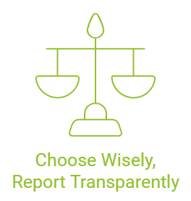
In 2023, over $650 billion was directed into ESG-focused investments worldwide. This significant movement underscores the growing influence of environmental, social, and governance (ESG) considerations in shaping the future business landscape. This chapter will guide you in developing a robust ESG reporting approach, transforming these considerations from potential obstacles into opportunities for growth and value creation.

Section 3.1: Selecting ESG Reporting Frameworks
Selecting the right ESG reporting framework is akin to laying the foundation for a skyscraper. Your choice will determine how well everything else holds together—your key performance indicators, your narrative to stakeholders, and the way your company measures success.
Key Factors to Consider When Selecting a Framework
Fit with Your Industry: Different sectors have different priorities—choose a framework that speaks to your business.
Stakeholder Expectations: Investors, employees, customers—know what matters to them.
Company Goals: Align the framework with your mission and sustainability objectives
In this section, we will help you navigate the leading ESG frameworks, enabling you to select one that best suits your industry, meets stakeholder expectations, and aligns with your strategic business goals.

3.2 Why ESG Reporting Matters
More Than Compliance: Why ESG Reporting is Transformative
ESG reporting goes beyond simply meeting regulatory requirements. It is about creating value, building credibility, and mitigating risk. When executed effectively, it becomes a growth tool that distinguishes your organisation from its competitors.
- Transparency and Trust: ESG reports give stakeholders—investors, employees, and the public—a clear view of how your company addresses critical ESG issues. This transparency builds credibility, strengthens brand trustworthiness, and attracts investors while helping recruit and retain top talent.
For example, in 2023, companies like Unilever reported increased brand trust and employee engagement after enhancing their ESG disclosures through GRI and CDP reporting.
A 2023 survey by Bloomberg found that 70% of global investors are more likely to invest in companies with transparent ESG practices.
.

- Spotting Risks and Opportunities: ESG data helps to identify risks—such as potential regulatory breaches—before they escalate. It also uncovers opportunities, such as entry into emerging sustainability markets. Engaging stakeholders through qualitative methods, such as interviews and focus groups, can reveal ESG risks that may not be immediately apparent through quantitative data alone, such as reputational risks linked to community relations.
- Attracting Investors: Increasingly, investors are seeking to support companies that prioritise their social and environmental impact. ESG reporting demonstrates your commitment to sustainability, making your business a more compelling investment prospect.

3.3 Overview of Major ESG Reporting Frameworks
There is no single ESG framework that suits every organisation—each has its own strengths, tailored to different needs. Below, we explore some of the most widely used frameworks and how they might benefit your company.
1. Global Reporting Initiative (GRI): The Big Picture Approach
What It’s About: The GRI framework enables companies to report on a broad range of topics—economic, environmental, and social. It is designed to help organisations tell the full story of their impact.
Why It’s Great:
Materiality Focus: Helps identify the most significant issues for both your company and its stakeholders, ensuring reporting is relevant and meaningful.
Comprehensive Scope: Covers a wide array of sustainability issues, offering a detailed and standardised method for disclosing performance.
External Assurance: Supports third-party verification of reports, enhancing credibility and transparency—particularly valuable for investors and regulators.
Quick Start Guide- GRI Reporting Steps:
- Conduct a Materiality Assessment: Use GRI’s guidelines to determine which topics (e.g. labour practices, environmental impacts) are most material, based on stakeholder engagement.
- Set Up Data Collection Systems: Establish systems for gathering data aligned with GRI indicators across departments.
- Modular Reporting: Begin with a small number of material topics to minimise workload, and gradually expand as your sustainability strategy develops.
- Industry Example: A manufacturing company might begin by reporting on emissions and waste management to address its most pressing material issues. Nestlé, for instance, initially encountered challenges due to the extensive data required for GRI reporting, but ultimately succeeded in producing a detailed and impactful sustainability report.
Company Spotlight: Ford Motor Company & GRI
Ford uses GRI to report on the progress of its climate change, human rights, and product responsibility. By adopting GRI, Ford has:
- Improved transparency: Provides stakeholders with a clear picture of its sustainability performance.
- Enhanced stakeholder engagement: Fostered dialogue with investors, NGOs, and communities.
- Strengthened its reputation: Positioned itself as a leader in sustainable mobility
2. Sustainability Accounting Standards Board (SASB): Connecting ESG to Financial Performance
What Its about: The SASB addresses the financial impact of sustainability issues. Its frameworks are designed to help companies disclose financially material information that influences investor decision-making.
Why its great:
  - Industry-Specific Standards: Provides standards tailored to 77 industries, recognising that materiality is not a one-size-fits-all concept.
  - Financial Relevance: Demonstrates how ESG factors affect a company’s financial performance.
  - Complementary Reporting: Works alongside other frameworks, such as the GRI, for companies seeking to report both financial implications and broader ESG metrics. SASB’s financial metrics can be integrated seamlessly with GRI’s wider sustainability disclosures, making it suitable for companies aiming to present a holistic view of sustainability impact and financial performance.
Suitable Industries: Ideal for sectors where financial materiality is critical, such as financial services, real estate, technology, and healthcare.
Quick Start Guide- SASB Reporting Steps:
- Download Industry-Specific Standards: SASB provides industry-specific metrics—focus on the standards relevant to your industry and review how they relate to your operations.
- Engage Financial Teams: Collaborate with your finance department to evaluate how each identified ESG factor impacts financial statements and investor concerns.
- Integrated Reporting: Incorporate SASB disclosures into your financial reports to clearly connect ESG issues with financial performance.
- Industry Example: A technology company might highlight data privacy as a key ESG risk, linking it directly to financial risk in order to address investor concerns.
Company Spotlight: JPMorgan Chase & SASB
JPMorgan Chase uses SASB standards to disclose its performance on climate risk, financial inclusion, and data security. By adopting SASB, JPMorgan Chase has:
- Improved investor communication: Provided investors with decision-useful ESG information.
- Enhanced risk management: Strengthened its understanding of ESG-related financial risks.
- Aligned with investor expectations: Met the growing demand for industry-specific ESG disclosures.

3. Task Force on Climate-related Financial Disclosures (TCFD): Navigating the Climate Challenge
What it's about: The TCFD provides a consistent framework for organisations to disclose climate-related risks and opportunities. It emphasises the financial implications of climate change and aims to enhance market resilience.
- Why its great:
  - Financial Stability: Encourages companies to consider climate risks in financial terms.
  - Risk and Opportunity Analysis: Covers both transition risks (e.g. policy changes) and physical risks (e.g. extreme weather events).
  - Integrated Reporting: Aligns well with other frameworks such as GRI and SASB.
- Suitable Industries: Particularly relevant for sectors that are sensitive to climate risks, such as energy, agriculture, transport, and utilities.
- What's Not Widely Shared: The TCFD recommendations can be adopted progressively. Companies may start by disclosing qualitative information (such as governance and strategy) before moving towards quantitative disclosures—making the reporting process more accessible for those beginning their journey.
Quick Start Guide -TCFD Reporting Steps:
Task Force on Climate-related Financial Disclosures (TCFD)
- Assess Climate-Related Risks and Opportunities: Identify transition risks (e.g. regulatory changes) and physical risks (e.g. natural disasters).
- Conduct Scenario Analysis: Use scenario analysis to explore how different climate pathways may impact your business model.
- Integrate into Strategic Reports: Embed climate risk disclosures within corporate risk management reports to ensure alignment with wider business strategies.
- Industry Example: An energy company might assess risks related to new carbon regulations and incorporate these insights into strategic planning.
Company Spotlight: ExxonMobil & TCFD
ExxonMobil uses TCFD to disclose its climate-related risks and opportunities, including its approach to carbon management and low-carbon technologies. By adopting TCFD, ExxonMobil has:
- Increased transparency: Provided investors with insights into its climate strategy.
- Improved risk management: Enhanced its assessment and management of climate-related risks.
- Demonstrated leadership: Showcased its commitment to addressing climate change.

Carbon Disclosure Project (CDP): A Deep Dive into Environmental Impact
What It’s about: CDP specialises in environmental reporting, focusing primarily on carbon emissions, water security, and forests.
- Why its great:
  - Data-driven: CDP’s questionnaires provide a comprehensive breakdown of environmental performance.
  - Integration with other frameworks: Frequently used alongside TCFD and GRI to enhance climate-related and broader sustainability disclosures.
- Suitable Industries: Relevant for sectors with significant environmental impacts, including automotive, chemicals, construction, and retail.
Pro Insight: CDP scores companies from A to D-, evaluating the depth of disclosure and the quality of data concerning climate, water, and forest-related impacts. A higher score indicates stronger environmental stewardship and transparency.

Quick Start Guide- CDP Reporting Steps
- Complete CDP Registration: Sign up with CDP to gain access to detailed questionnaires covering emissions, water use, and forestry impacts.
- Collaborate Across Departments: Gather specific environmental data from operations, supply chains, and facilities management.
- Set Clear Targets: Align the collected data with defined reduction goals, such as adopting science-based emissions targets, to achieve a higher CDP score.
Company Spotlight: Walmart & CDP
Walmart uses CDP to report on its climate change initiatives, including its efforts to reduce emissions in its operations and supply chain. By participating in CDP, Walmart has:
- Tracked its progress: Monitored its performance on key environmental metrics.
- Engaged with investors: Communicated its climate strategy to investors and stakeholders.
- Improved its environmental performance: Driven reductions in its carbon footprint.
.
5. United Nations Sustainable Development Goals (SDGs): Aligning with Global Goals
What It’s about: The 17 SDGs provide a comprehensive framework to address global challenges such as poverty, inequality, climate change, and environmental degradation.
Why it’s great:
  - Global Focus: Connects business activities to broad global sustainability objectives.
  - Flexibility: Allows companies to select specific goals aligned with their operations and values.
Suitable Industries: Applicable across sectors, especially where businesses seek to demonstrate alignment with social and environmental causes – including education, agriculture, pharmaceuticals, and technology.
Quick Start Guide-SDG Reporting Steps
United Nations Sustainable Development Goals (SDGs)
- Align Goals with Business Activities: Identify SDGs that closely relate to your core operations (e.g. gender equality for socially-focused organisations).
- Define Contribution Metrics: Establish specific, measurable targets – such as reducing waste by a certain percentage or expanding community support initiatives.
- Collaborate with External Partners: Work with NGOs, suppliers, or industry associations to strengthen the credibility and impact of your SDG contributions.
- Industry Example: An agricultural business might align with the “Zero Hunger” SDG to emphasise its role in sustainable food production.
Company Spotlight: IKEA & the SDGs
IKEA has embedded the SDGs into its business strategy, focusing on goals related to sustainable consumption, climate action, and gender equality. By aligning with the SDGs, IKEA has:
- Reduced its environmental impact: Committed to becoming climate-positive by 2030.
- Improved social conditions: Promoted sustainable sourcing and fair labour practices in its supply chain.
- Enhanced brand value: Strengthened its reputation as a responsible and sustainable company.

6. International Integrated Reporting Council (IIRC): Connecting the Dots
- What it's about: Integrated reporting that explains how a company's strategy, governance, and performance lead to value creation over time.
- Why it's great:
  - Holistic View: Combines financial and non-financial reporting. Integrated reporting under the IIRC ensures that stakeholders understand how non-financial factors, such as human capital (e.g., employee satisfaction), influence financial performance. This creates a cohesive narrative about value creation.
  - Strategic Insights: Highlights how ESG initiatives contribute to long-term value creation.
Suitable Industries: Applicable across all industries, particularly valuable for organisations seeking to demonstrate a clear connection between financial success and sustainability initiatives.
Quick Start Guide - IIRC Reporting Steps:
- Identify Capitals Used: Review the six types of capital (e.g., financial, human, natural) that your organisation depends on or affects.
- Link Capitals to ESG Goals: Explain how improvements in ESG initiatives (e.g., reducing emissions) will enhance long-term value across these capitals.
- Create an Integrated Value Story: Combine financial and ESG performance in a single report, demonstrating how your sustainability initiatives contribute to future profitability.
- Industry Example: A financial services firm could link human capital (e.g., employee well-being initiatives) to profitability and long-term value creation. JP Morgan has exemplified this approach by directly connecting its diversity and inclusion programmes to value creation, emphasising long-term sustainability.
Company Spotlight: Microsoft & IIRC
Microsoft uses integrated reporting to communicate its performance on key ESG issues, such as carbon emissions, diversity and inclusion, and responsible AI. By adopting IIRC, Microsoft has:
- Improved transparency: Provided stakeholders with a comprehensive view of its performance.
- Enhanced accountability: Demonstrated its commitment to sustainable value creation.
- Strengthened investor relations: Communicated its long-term value creation story to investors.

3.4 How to Choose the Right ESG Reporting Framework
Selecting the proper framework can feel overwhelming. Here's a simplified process:
(Step 1) Assess Industry and Material Issues:
- What are the most critical ESG issues in your industry?
Example: A clothing manufacturer with a global supply chain might prioritise frameworks such as the GRI and the SDGs to address social issues, including fair labour practices and ethical sourcing. In contrast, manufacturers with significant resource use should focus on frameworks like the GRI and CDP to highlight their environmental impact.

(Step 2) Understand Stakeholder Expectations:
- Who are your key stakeholders? (Investors, customers, employees, communities, regulators).
- What ESG information are they most interested in? (Engage with them through surveys, interviews, or focus groups.)
Example: If investors prioritise financial impacts, SASB may be the right fit, while GRI may be better if stakeholders seek comprehensive sustainability reporting.
(Step 3) Local vs. Global Compliance:
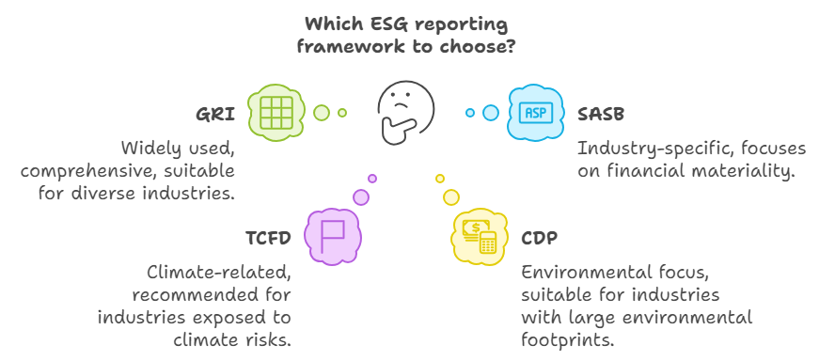
- Where does your company operate? Consider any region-specific reporting requirements.
Example: EU-based companies may benefit from frameworks such as the GRI or the SDGs for standardised global reporting, while the TCFD can help address specific regional climate mandates, including the UK’s requirement for TCFD-aligned disclosures by 2023.
Summary Table:
Step | Description | Example
1. Assess Industry Needs | Identify critical ESG issues specific to your industry. | Clothing manufacturer focusing on fair labor (GRI, SDGs).
2. Stakeholder Expectations | Determine what information stakeholders value most. | Investors seeking financial materiality may prefer SASB.
3. Local vs. Global Compliance | Consider both local and global compliance needs. | EU-based companies may need GRI for standardization, TCFD for climate.

To help you navigate these considerations and make an informed decision, you may use the following worksheet:
Framework Selection Worksheet
This worksheet summarises the key factors to consider when selecting an ESG reporting framework. Use it to assess your company's needs and prioritise the frameworks that best align with your goals.
  - Understand Your Company Worksheet: This table includes factors such as industry, business activities, geographic location, company size and resources, business goals, and current practices, enriched with relevant frameworks, impact metrics, and references to regulations.
Factor | Consideration | Notes/Examples | Relevant Frameworks | Impact Metrics | Regulatory Requirements Reference
Industry | Key ESG issues in your industry? | Tech - Data Privacy, Manufacturing - Emissions | GRI, SASB | Data privacy, Emissions | -
Business Activities | Core operations and their impact? | Products/services, resource use, waste generation | GRI, CDP | Carbon Footprint, Waste | -
Geographic Locations | Regional reporting requirements? | EU CSRD, SEC disclosure rules in the US | EU CSRD, SEC | - | EU CSRD
Company Size & Resources | Available resources for reporting? | Staff time, budget, and data collection capabilities | GRI, SASB | Resource efficiency, Accuracy
Business Goals | ESG reporting & strategic objectives? | Improve brand reputation, attract investors | IIRC, GRI | Investor engagement, Brand value
Current Practices | Existing ESG initiatives? | Current policies, data systems, and sustainability programs | SDGs, GRI | Policy adherence, Coverage of ESG metrics

  - Your Stakeholders Worksheet: This focuses on identifying stakeholders, understanding their needs, and prioritising their concerns through specific engagement methods and consideration of stakeholder preferences.
Stakeholder Engagement | Consideration | Notes/Examples
Identify Key Stakeholders | Who are your primary stakeholders? | Investors, Customers, Employees, NGOs.
Understand Needs | What ESG info do they need? | Surveys, Interviews, Stakeholder dialogues.
Prioritise Concerns | How urgent and legitimate are concerns? | Develop an engagement plan to address key concerns.

  - ESG Reporting Frameworks Comparison Worksheet: A detailed comparison of different frameworks (e.g., GRI, SASB, TCFD), including focus areas, suitable industries, reporting emphasis, challenges, and possible integrations with other frameworks.
Framework | Focus Areas | Suitable Industries | Reporting Emphasis | Best For
GRI | Broad sustainability topics (economic, environmental, social) | All industries, particularly those with significant environmental and social impacts | Materiality and broad stakeholder engagement | Companies seeking comprehensive sustainability reporting.
SASB | Financial materiality of ESG issues | Financial Services, Real Estate, Healthcare | Industry-specific standards, financial impact | Companies prioritising financial materiality of ESG factors
TCFD | Climate-related financial risks | Energy, Agriculture, Utilities, Transport | Financial stability, climate resilience | Companies seeking to understand and disclose climate-related financial risks and opportunities
CDP | Carbon emissions, water, forests | Automotive, Chemicals, Construction | Environmental focus (carbon, water, forest) | Companies prioritising transparency and action on climate change, water security, and deforestation
SDGs | Global goals for sustainable development | All industries, with particular relevance for those addressing social and environmental challenges | Alignment with global sustainability goals | Companies seeking to align with global sustainability goals
IIRC | Integrated reporting and value creation | All industries | Integrated financial and non-financial information | Companies aiming to integrate financial and non-financial reporting to demonstrate value creation

Choosing the appropriate ESG reporting framework is crucial for developing a practical and comprehensive sustainability strategy. By understanding your industry’s needs, stakeholder expectations, and compliance requirements, you establish the foundation for meaningful and impactful ESG reporting. With this framework in place, we can now turn to the broader context of ESG today—including key regulatory developments and evolving stakeholder demands that shape reporting strategies.

3.5 ESG in the News
- The Rise of Mandatory ESG Disclosure: Governments across the globe are increasingly requiring companies to disclose ESG information. In 2023, the European Union introduced additional obligations under the Corporate Sustainability Reporting Directive (CSRD), making it mandatory for companies to report comprehensive ESG data.
- Rising Investor and Regulatory Pressure: Investors and regulators are demanding greater transparency and accountability on ESG issues. Meeting these growing expectations is essential for remaining competitive and ensuring that your business aligns with global best practices. The SEC’s climate disclosure proposal in the United States exemplifies the mounting pressure for standardised ESG transparency, particularly for listed companies.
- Heightened Focus on Climate Risk: With climate change a central concern for both investors and regulators, staying informed about developments in climate-related disclosures—such as those under the Task Force on Climate-related Financial Disclosures (TCFD)—is key to understanding and mitigating potential risks.
For example, the UK required companies to align their climate disclosures with TCFD guidelines by 2023, underscoring the increasing regulatory emphasis on climate risk transparency.
Key Takeaways: ESG Reporting Frameworks at a Glance
  - ESG Reporting Frameworks Are Foundational:
- Choosing the appropriate framework is akin to laying a strong foundation for your sustainability strategy. Your selection will influence everything—from performance indicators to stakeholder communications.

  - Frameworks Have Different Strengths:
- Global Reporting Initiative (GRI): The most comprehensive framework, ideal for capturing a wide range of economic, social, and environmental impacts. Best suited to organisations seeking a broad sustainability scope.
- Sustainability Accounting Standards Board (SASB): Focuses on financial materiality and industry-specific standards, linking ESG issues directly to financial outcomes. Most effective for appealing to financially motivated stakeholders.
- Task Force on Climate-related Financial Disclosures (TCFD): Emphasises climate-related risks and their financial implications. Particularly relevant to sectors significantly affected by climate change, such as energy and agriculture.
- Carbon Disclosure Project (CDP): Specialises in environmental transparency, with a focus on carbon, water, and forests. Essential for organisations aiming to demonstrate climate commitment through scored disclosures.
- United Nations Sustainable Development Goals (SDGs): Connects business operations to global sustainability objectives, offering flexibility to align with the goals most relevant to your mission.
- International Integrated Reporting Council (IIRC): Merges financial and non-financial information into a single integrated report, linking sustainability initiatives directly to value creation.
  - Consider Industry Needs and Stakeholder Expectations:
- No single framework suits every organisation. Begin by evaluating your industry, identifying the most pressing ESG issues, and understanding stakeholder expectations. For instance, manufacturers may prioritise GRI and CDP, while financial services firms might favour SASB or IIRC.
  - Align ESG Reporting with Business Goals:
- ESG reporting should go beyond regulatory compliance. It should align with your strategic objectives, reinforce brand values, and support long-term growth.
  - Use Multiple Frameworks for a Comprehensive View:
- Frameworks can be complementary. For example, GRI can provide a broad sustainability perspective, SASB can focus on financial relevance, and TCFD can address climate-related disclosures, offering a holistic view.
  - Start Small and Scale Up:
- If ESG reporting is new to your organisation, consider beginning with modular frameworks like GRI or the SDGs. Start with a few material topics and expand as your sustainability initiatives mature. The goal is continuous improvement—not perfection.
  - Practical Next Steps for Framework Selection:
- Use the accompanying Framework Selection Worksheet to identify the most appropriate framework based on your industry, stakeholder priorities, and strategic goals.

3.6 Conclusion
Selecting an ESG framework establishes the structure for your reporting, while conducting a materiality assessment ensures focus on the most impactful issues. In Chapter 4, we will examine how to conduct a materiality assessment, enabling you to tailor your reporting and maximise its effectiveness.

References
5 Key Steps to Prepare for ESG Disclosure Regulations. https://www.yarooms.com/blog/5-key-steps-to-prepare-for-esg-disclosure-regulations
NEC named to the CDP "A-List" for advanced Climate Change and Water Security initiatives: Press Releases | NEC. https://www.nec.com/en/press/202002/global_20200205_03.html
Bloomberg Intelligence. (2023). ESG Market Outlook: 2023 Investment Trends. Bloomberg. Retrieved from https://www.bloomberg.com
BlackRock. (2023). Global Investor Pulse Survey: ESG Insights. BlackRock Inc. Retrieved from https://www.blackrock.com
CDP. (2023). Scoring Introduction and Methodology Report. Carbon Disclosure Project. Retrieved from https://www.cdp.net
Deloitte. (2023). Corporate Sustainability Reporting Directive (CSRD): Overview and Compliance Guide. Deloitte Insights. Retrieved from https://www2.deloitte.com
European Commission. (2023). Corporate Sustainability Reporting Directive (CSRD). European Commission. Retrieved from https://ec.europa.eu
EY. (2023). Global Institutional Investor Survey: ESG Perspectives. Ernst & Young. Retrieved from https://www.ey.com
Financial Times. (2023). How Unilever Improved Brand Trust through ESG Disclosures. Financial Times. Retrieved from https://www.ft.com
JP Morgan Chase & Co. (2023). Environmental and Social Policy Framework. JP Morgan Chase & Co. Retrieved from https://www.jpmorganchase.com
Morningstar. (2023). Sustainable Funds Landscape Report. Morningstar Inc. Retrieved from https://www.morningstar.com
Shell. (2023). Climate Strategy and TCFD Compliance Report. Royal Dutch Shell. Retrieved from https://www.shell.com
Sustainability Accounting Standards Board (SASB). (2023). Industry-Specific Standards and Financial Implications. SASB. Retrieved from https://www.sasb.org
Unilever. (2023). Sustainable Living Plan: ESG Report 2023. Unilever. Retrieved from https://www.unilever.com
United Nations Global Compact. (2023). Danone and SDG Alignment: A Case Study. United Nations. Retrieved from https://www.unglobalcompact.org
U.S. Securities and Exchange Commission (SEC). (2023). SEC Proposal for Climate-Related Disclosures. U.S. Securities and Exchange Commission. Retrieved from https://www.sec.gov
Yarooms. (2023). 5 Key Steps to Prepare for ESG Disclosure Regulations. Yarooms Blog. Retrieved from https://www.yarooms.com/blog/5-key-steps-to-prepare-for-esg-disclosure-regulations

Appendix A: Comprehensive Comparison of Major ESG Reporting Frameworks
Aspect | Global Reporting Initiative (GRI) | Sustainability Accounting Standards Board (SASB) | Task Force on Climate-related Financial Disclosures (TCFD) | Carbon Disclosure Project (CDP) | United Nations Sustainable Development Goals (SDGs) | International Integrated Reporting Council (IIRC)
Purpose | To disclose sustainability impacts across economic, environmental, and social dimensions. | To report financially material ESG issues relevant to investor decision-making, with industry-specific standards. | To provide consistent disclosure of climate-related risks and opportunities, focusing on financial impacts. | To measure environmental impacts, specifically focusing on carbon emissions, water security, and forests. | To align corporate activities with global sustainability goals aimed at tackling issues like poverty, inequality, and climate change. | To create a cohesive, integrated report combining financial and non-financial performance for value creation.
Focus Areas | Economic, environmental, and social performance. | Financial materiality of sustainability factors, tailored by industry. | Climate-related risks and opportunities, focusing on financial stability. | Environmental issues, particularly climate change, water, and deforestation. | Broad global sustainability goals covering social, environmental, and economic development. | Value creation over time by integrating governance, strategy, and performance (financial and non-financial).
Strengths | - Comprehensive Scope: Addresses a wide range of sustainability issues.  - Materiality: Emphasizes material ESG topics important to stakeholders.  - External Assurance: Encourages third-party verification, enhancing credibility. | - Industry-Specific Standards: Provides metrics for 77 industries.  - Financial Relevance: Focuses on issues that materially affect financial performance.  - Integration: Complements frameworks like GRI. | - Financial Focus: Aligns climate risks with financial implications, enhancing market resilience.  - Scenario Analysis: Encourages the use of scenario analysis for strategic planning. | - Data-Driven: Uses detailed questionnaires, making the reporting process structured and data-intensive.  - Investor Focus: Scoring mechanism directly impacts investor perception. | - Flexibility: Companies can choose specific SDGs that align with their mission.  - Global Alignment: Links corporate activities to broad, universally recognized goals. | - Holistic View: Combines financial and non-financial metrics in a single report.  - Stakeholder Communication: Focuses on communicating how sustainability initiatives drive long-term value.
Challenges | - Data Complexity: Collecting data for multiple areas can be resource-intensive.  - Broad Scope: May be overwhelming for smaller companies with limited resources. | - Data Quality Requirements: Requires high-quality, consistent data, especially for financial metrics.  - Less Broad: Focuses less on broader sustainability issues and more on financially material elements. | - Complexity of Scenario Analysis: Conducting scenario analysis requires expertise and can be resource-demanding.  - Heavy Emphasis on Climate: May not fully address other ESG factors beyond climate risks. | - Data Burden: Requires extensive data collection across multiple departments.  - High Expectations: Performance scoring can create pressure to achieve high ratings. | - Broad Scope: Aligning specific corporate activities to overarching SDGs may be difficult.  - Reporting Not Standardized: SDG-related reporting lacks specific, standardized metrics. | - Integration Complexity: Creating a single cohesive report that includes both financial and non-financial elements can be challenging for companies not accustomed to integrated reporting.
Suitable Industries | Applicable across all industries, especially those with significant social or environmental impacts. | Financial services, real estate, healthcare, technology, and industries where financial materiality of ESG issues is a priority. | Energy, agriculture, utilities, transportation, and other sectors with high exposure to climate risks. | Automotive, chemicals, construction, and industries with significant environmental impacts. | Adaptable to all industries, particularly where alignment with social or environmental goals is crucial (e.g., agriculture, education, healthcare). | Suitable across industries, especially for those aiming to communicate how ESG initiatives drive overall business value.
Best For | - Companies seeking comprehensive sustainability reporting.  - Organizations wanting to address a broad audience, including NGOs, customers, and employees. | - Companies prioritizing financial materiality of ESG impacts.  - Firms seeking investor engagement based on industry-specific risks. | - Organizations looking to understand and disclose climate-related financial risks and improve resilience.  - Firms needing compliance with climate mandates (e.g., EU TCFD requirements). | - Companies focusing on environmental impacts such as emissions and resource use.  - Organizations aiming for high transparency on climate and natural resource issues. | - Firms wanting to demonstrate alignment with global goals.  - Companies seeking flexibility in which sustainability issues they focus on. | - Companies wanting to integrate sustainability into financial reporting.  - Firms aiming to show how value creation is influenced by sustainability and governance practices.
Integration with Other Frameworks | - Works well with SASB to balance broad sustainability and financial materiality.  - Complements CDP for environmental transparency. | - Can be used alongside GRI to provide a balance between financial and non-financial materiality.  - Complements IIRC for an integrated approach. | - Often integrated with CDP for environmental metrics.  - Works well with GRI to include broader ESG issues alongside climate risk. | - GRI and TCFD are commonly used in conjunction with CDP to provide comprehensive environmental and climate risk disclosures. | - Supports reporting based on GRI and TCFD, providing context to align with global development goals. | - Can be integrated with SASB and GRI for more holistic value-driven reporting.
Data Requirements | - Requires qualitative and quantitative data, often from diverse operational areas.  - Emphasis on stakeholder engagement and materiality assessment. | - Relies heavily on financial data and metrics that are sector-specific.  - Data quality must meet standards for investor decision-making. | - Requires climate-related data, including governance, strategy, and scenario analysis inputs.  - Strong emphasis on linking climate information to financial statements. | - Focuses on quantitative environmental data (e.g., emissions, water usage).  - Requires data from across operational and supply chain aspects. | - Qualitative and quantitative data based on the company's chosen goals.  - Focus on impact metrics aligned with SDGs (e.g., poverty reduction, education programs). | - Relies on a combination of six types of capitals (financial, human, social, natural, intellectual, and manufactured).  - Data integration across different dimensions of value creation.
External Assurance and Credibility | - Strongly encourages third-party assurance to verify data quality and build trust. | - Assurance is beneficial but not mandatory; credibility is mainly established through financial audit alignment. | - Assurance is typically required for scenario analysis and climate risk disclosures. | - External verification strengthens credibility; scoring directly affects stakeholder trust. | - External assurance varies by company; alignment with UN Global Compact boosts credibility. | - Assurance for integrated reports is often sought to verify consistency between financial and non-financial data.
Scoring Mechanism | - No formal scoring, but reports are evaluated based on adherence to GRI Standards. | - No scoring, but financial stakeholders evaluate disclosures on industry-specific compliance and detail. | - No direct scoring, but qualitative and quantitative disclosure assessments provide guidance on completeness. | - Scoring from A to D-, based on completeness and accuracy of environmental data.  - Scoring impacts public perception and investor confidence. | - No formal scoring; success is measured based on contribution to each selected SDG. | - No scoring mechanism; the emphasis is on integrating sustainability with financial outcomes to show value creation.
Real-World Example Companies | - Nestlé uses GRI for comprehensive ESG disclosures, focusing on both environmental and social metrics. | - JP Morgan uses SASB standards to align financial and ESG impacts across their operational sectors. | - Shell implemented TCFD to disclose climate risk and align its climate strategy with financial implications. | - Tesla uses CDP to score its environmental transparency, particularly regarding carbon emissions and resource use. | - Danone aligns its operations with SDGs, focusing on clean water and responsible consumption goals. | - Unilever employs IIRC to show how sustainability initiatives create long-term value for investors and stakeholders.
Summary and Key Insights:
- GRI provides abroad, comprehensive view of a company’s environmental, social, and economic impacts, making it ideal for companies wanting to communicate their overall ESG performance to a wide range of stakeholders, including NGOs, employees, and customers.
- SASB is particularly well-suited for companies focused on demonstrating the financial materiality of sustainability issues, especially in industries with specific ESG risks impacting financial performance. It works well in tandem with other frameworks like GRI to add depth in the financial realm.
- TCFD focuses explicitly on climate-related financial risks and is especially useful for industries exposed to high climate risk, such as energy, agriculture, and transportation. It helps companies think about climate risk strategically, linking it directly to their financial health.
- CDP is a highly data-driven framework focused on environmental metrics, such as carbon emissions, water usage, and deforestation. The scoring mechanism provides a transparent evaluation of a company’s performance, which can be beneficial for investor perceptions.
- SDGs offer flexibility and a link to globally recognized sustainability goals, making them ideal for companies looking to align their activities with broad social and environmental targets. The framework allows companies to choose specific goals that resonate with their values and operations.
- IIRC is best for companies that want to provide a cohesive view of how their sustainability practices contribute to financial performance and overall value creation. It integrates both financial and non-financial metrics, which is particularly powerful for companies wishing to demonstrate the broader value of their sustainability strategies to investors and other financial stakeholders.
Key Considerations for Framework Selection:
- Industry Relevance: Different industries may require distinct frameworks. For instance, financial services and technology firms may benefit from SASB's focus on financial materiality, whereas agriculture companies may benefit more from SDGs and TCFD.
- Integration Potential: Often, no single framework is sufficient. Many companies use a combination of frameworks to provide a more comprehensive view. For example:
  - Nestlé integrates GRI for general sustainability and CDP for environmental scoring.
  - JP Morgan uses SASB for financial-specific metrics and combines this with IIRC to illustrate the overall value.
- Stakeholder Expectations: Identify what information stakeholders (e.g., investors, customers, regulatory bodies) value most. If investors are the primary target, SASB and TCFD are more likely to satisfy their needs for financial materiality and climate risk. For broader public and regulatory engagement, GRI and SDGs may be more effective.
Benefits of Using Multiple Frameworks:
- Holistic Reporting: Using GRI, SASB, and TCFD together provides a well-rounded report that addresses a broad spectrum of sustainability issues while also satisfying financial and climate-specific requirements.
- Enhanced Credibility: A combination of frameworks can strengthen credibility. For instance, GRI's stakeholder engagement focus can be supplemented by CDP’s environmental transparency to assure stakeholders of both environmental and broad social impact.
- Strategic Alignment: Integrated reporting via IIRC combined with SDGs can clearly communicate how a company’s activities contribute to both financial performance and global sustainability.
Practical Steps for Implementing ESG Reporting Frameworks:
- Identify Material Issues: Begin by assessing your industry and determining the most critical ESG topics. Use GRI for broad issues and SASB for financially material issues.
- Engage Stakeholders: Determine what your stakeholders value most. Investors may lean towards SASB and TCFD, while broader social engagement may be addressed via GRI and SDGs.
- Data Integration and Collection: Set up systems for collecting data across departments. Use CDP for environmental data, SASB for industry-specific metrics, and GRI for a wide range of sustainability issues.
- Combine Reporting Approaches: Use IIRC to create an integrated report that ties all the data together in a cohesive narrative, highlighting value creation.
Conclusion:
This comprehensive comparison of ESG frameworks is intended to help companies navigate the range of available options. No single framework will meet all needs entirely; however, understanding the strengths, weaknesses, and potential for integration of each can support a more strategic approach to ESG reporting. By selecting and combining the most appropriate frameworks, a company can foster transparency, enhance credibility, and align its ESG efforts with both financial objectives and global sustainability goals.
Visual Summary for Integration Possibilities:
- Diagram Suggestion: A Venn diagram with intersecting areas illustrating common integration points between frameworks (e.g., GRI, CDP, and TCFD overlapping on climate reporting; SASB and IIRC on financial integration). This can serve as a visual aid to demonstrate how multiple frameworks can be used together effectively.

Chapter 4: Materiality and Double Materiality Assessments

4.1 What is a Materiality Assessment?
A materiality assessment is a vital component of an Environmental, Social, and Governance (ESG) strategy. It enables companies to identify the most significant ESG issues that could affect their operations and stakeholders. Put simply, a materiality assessment is a tool for determining what truly matters on a company’s journey towards sustainability.
In ESG, not every issue is relevant to every company. For example:
- A railway company might prioritise issues such as biodiversity, given the disruption to ecosystems during construction.
- A retail chain might focus on supply chain transparency and product sustainability.
In other words, materiality is highly context-specific, varying by industry, geography, and stakeholder expectations.

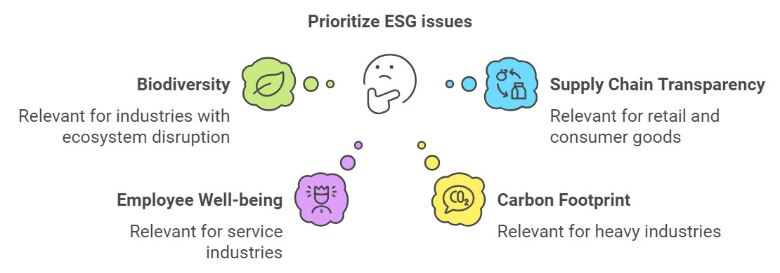
Why Materiality is Essential?
Materiality assessments enable companies to allocate resources effectively and align with stakeholder expectations. In today’s interconnected world, stakeholders—employees, investors, customers, and the wider community—demand greater accountability.
Failure to prioritise key ESG issues can damage a company’s reputation, hinder long-term growth, and even result in legal consequences.
Historically, businesses have focused on financial materiality, which pertains to financial risks or benefits that directly affect business performance. However, the scope has since broadened to include ESG materiality, which encompasses not only financial concerns but also environmental and social impacts.
Regulatory standards such as the EU’s Corporate Sustainability Reporting Directive (CSRD) have further increased demands for transparency, encouraging companies to evaluate both financial and ESG materiality.
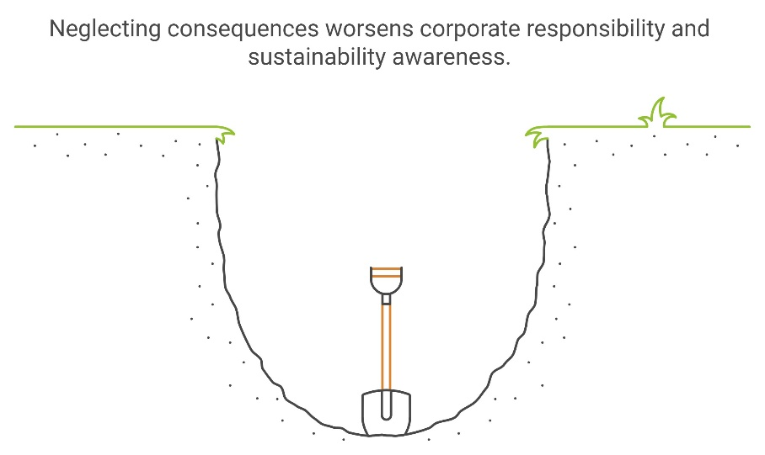

4.2 Conducting a Materiality Assessment: A Step-by-Step Guide

Step 1: Identify Stakeholders
The first and most crucial step in a materiality assessment is identifying your stakeholders. Stakeholders include anyone affected by, or able to influence, your company's ESG performance. They may be internal or external, and accurately identifying them ensures that your ESG strategy addresses genuine concerns.
Who Are Your Stakeholders?
- Internal Stakeholders
  - Employees: Include individuals from all levels, from top executives to frontline workers.
  - Board Members: They play a crucial role in governance and strategic development.
  - Investors and Shareholders: Directly invested in the company’s financial success and often vocal about governance and sustainability risks.
- External Stakeholders
Customers: Growing demand for sustainable products means customers care deeply about ESG practices.
Suppliers: Their environmental and social practices directly affect your company.
Local Communities: Especially important for companies with a physical footprint (e.g., manufacturing plants).
NGOs and Advocacy Groups: Special interest groups focusing on issues like human rights, biodiversity, and climate change.
Regulators: Ensure your company complies with national and international laws.

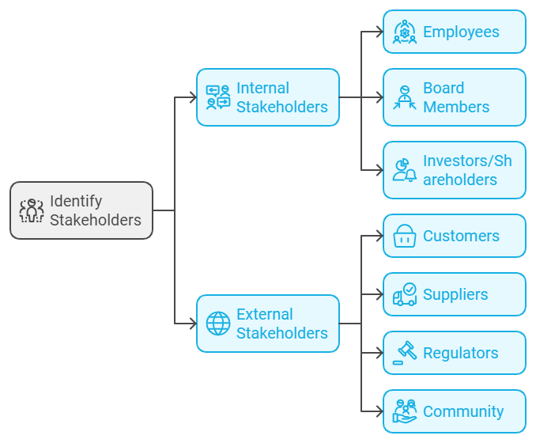

Using a Stakeholder Matrix
Once stakeholders have been identified, categorise them based on their influence and interest in your ESG issues. A Stakeholder Matrix helps to visualise this categorisation, providing a structured method for prioritising stakeholders.
Practical Tools: Use software such as Miro or Lucidchart to create digital versions of the Stakeholder Matrix. These tools are particularly useful for collaboration, especially in hybrid or remote environments, as they make it easier to engage multiple teams in the materiality process.
Why Stakeholder Input Matters
Gathering feedback from stakeholders helps ensure that your assessment is not internally biased. It prevents 'blind spots' by incorporating all relevant perspectives, which is especially important for businesses with a wide-reaching impact, such as those with global supply chains..
Pro Tip: Begin by listing all possible stakeholders, even those with less obvious connections to your business. Then, narrow them down using your matrix to focus on key stakeholders with the m11ost influence and interest.

Step 2: Identify ESG Issues Relevant to Your Industry
Once you have identified your stakeholders, the next step is to map out the ESG issues most relevant to your business and industry. It is important to remember that not all ESG issues will apply equally to every company..
For example:
- A tech company might prioritize data privacy and cybersecurity, while a mining company might focus on biodiversity and local community impacts.
Practical Frameworks for ESG Issues Identification:
- The SASB Materiality Map is an excellent resource for identifying industry-specific material issues. This tool allows companies to identify which sustainability issues are most likely to impact financial performance, categorized by industry.
- The GRI Standards provide a broad overview of material issues across environmental, social, and governance categories. The GRI 101: Foundation and GRI 103: Management Approach standards can guide companies in identifying and managing material topics
Examples of ESG Issues
Environmental Issues
- Water Scarcity and Quality: Crucial for industries like agriculture, manufacturing, and utilities.
- Air Quality: A significant issue for transportation and industrial companies.
- Biodiversity: Particularly relevant for construction, energy, and extractive industries.
- Waste Management: Important for manufacturing, retail, and food industries.
- Circular Economy: A focus on reusing, recycling, and reducing waste, applicable to product-driven sectors.
Social Issues
- Health and Safety: Essential for industries like construction, transportation, or manufacturing.
- Community Engagement: Engaging with local communities is critical for companies operating near residential areas or in resource-extractive industries.
- Human Rights and Labor Practices: Particularly relevant for companies with global supply chains, where labor practices may vary widely.
Governance Issues
- Board Composition: Ensuring diversity and independence in leadership.
- Executive Pay: Tying compensation to ESG goals can motivate leadership to achieve sustainability targets.
- Transparency: Clear and accurate ESG data reporting is becoming a baseline expectation for all stakeholders.
Tip: Look at your industry peers to identify the ESG issues they prioritize. This will provide insight into common industry-wide challenges and help ensure you don’t overlook important areas.

Step 3: Engage Stakeholders

Survey and Stakeholder Engagement Tools
There are multiple ways to gather feedback from stakeholders, and each method has its own strengths:
- Surveys
Surveys are useful for quickly gathering feedback from a large number of people. They are cost-effective but may lack detailed responses.
- Emails or Letters
Personalized emails or letters are good for getting specific feedback from high-priority stakeholders. However, this method is time-consuming.
- Interviews or Focus Groups
Interviews or focus groups provide detailed insights. This is ideal for understanding the concerns of key stakeholders like investors or board members but requires significant time and resources.
- Public Forums or Town Halls
These events are best for engaging communities directly impacted by the company’s operations. They promote transparency but require preparation.

Developing a Stakeholder Engagement Plan
A successful engagement plan should address:
- Who: Determine which stakeholders need to be engaged.
- How: Choose the method of engagement (surveys, interviews, forums).
- What: Define what information you need (e.g., ESG priorities).
- When: Establish a timeline for when each group will be engaged.
Pro tip : Make sure your engagement process is inclusive. For example, offering materials in different languages or providing online options can encourage more diverse participation.
Engagement Method | Best Use Case | Pros | Cons
Surveys | Gathering mass feedback from stakeholders | Efficient, cost-effective | Limited depth in responses
Emails/Letters | Formal feedback from high-priority stakeholders | Personalized communication | Time-consuming
Interviews/Focus Groups | In-depth insights from investors or board members | Detailed responses | Resource-intensive
Public Forums/Town Halls | Addressing community impacts | Transparent, inclusive | May require significant preparation

Developing a Stakeholder Engagement Plan
The plan should outline:
- Who: Internal and external stakeholders.
- How: Surveys, interviews, emails, public forums.
- What: Information needed (ESG issues prioritization).
- When: Timeline for engagement
Tip: Ensure that your engagement methods are inclusive and accessible. For example, providing translated materials or offering virtual participation options can help to ensure broader involvement from diverse stakeholder groups.

Step 4: Analyze and Rank ESG Issues
After gathering feedback from stakeholders, it is time to analyse and prioritise the ESG issues. This step involves identifying which issues are most critical to both the company’s success and its stakeholders’ concerns..
Using a Materiality Matrix
A Materiality Matrix is a visual tool used to plot ESG issues according to their importance to stakeholders (horizontal axis) and their impact on the business (vertical axis). Here is how to interpret the matrix:
- Upper right quadrant: High importance to stakeholders, high impact on the business (These are your top priorities).
- Lower left quadrant: Low importance to stakeholders, low impact on the business (These issues can be deprioritized).
- Upper left quadrant: High importance to stakeholders, low business impact (Monitor but allocate fewer resources).
- Lower right quadrant: Low importance to stakeholders, high business impact (Monitor closely).
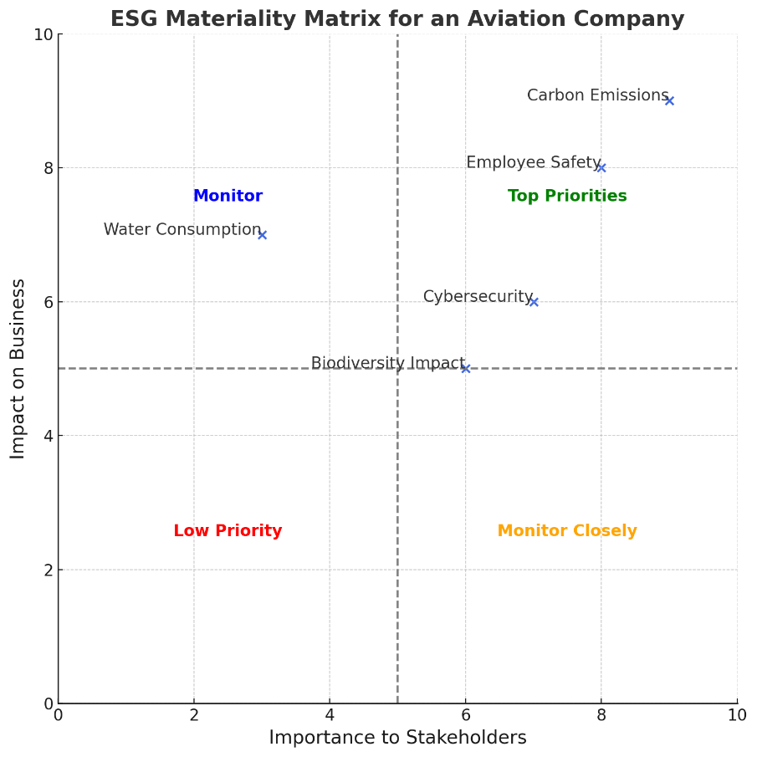
Example: For an aviation company, carbon emissions may appear in the upper-right quadrant, reflecting their high importance to both stakeholders and the business. Conversely, an issue such as water consumption at airports may fall into the lower-right quadrant, as it has a significant operational impact but is of lesser concern to stakeholders.

Steps to Build a Materiality Matrix
- Plot your issues: Use your stakeholder feedback and business analysis to plot each ESG issue on the matrix based on two dimensions: stakeholder interest and business impact.
- Determine priorities: The upper right quadrant of the matrix (high impact on business, high importance to stakeholders) should be the focus of your ESG strategy.
- Communicate findings: Once the matrix is developed, communicate these findings internally to ensure alignment across teams. The materiality matrix serves as a visual tool that simplifies decision-making and clarifies priorities.

4.3 Validating Findings with Leadership
After analysing and ranking ESG issues, the next critical step is to validate the findings with the leadership team. This ensures that the materiality assessment aligns with the company’s strategic objectives and resource capabilities.
Why Validation with Leadership is Crucial
Without leadership buy-in, even the most well-crafted ESG strategies can falter. The validation process allows for:
- Strategic Alignment: Strategic Alignment: Ensuring that prioritized ESG issues align with the company’s long-term goals and risk tolerance.
- Resource Allocation: Leadership needs to decide how to allocate financial and human resources to address these material issues effectively.
- Long-Term Buy-In: Leadership must fully understand and commit to addressing material ESG issues. They need to ensure that sustainability goals are integrated into day-to-day decision-making and not treated as standalone projects.
Key Points for Validating with Leadership
1. Present the Materiality Matrix
- Present your findings to the executive team and board members, including the top priorities identified through the matrix.
- Use data-driven insights to explain why certain issues were ranked highly by stakeholders and how they impact the company’s future.
2. Align with Corporate Goals
- Leadership should review whether the prioritized ESG issues fit within the company’s broader strategic vision.
  - Example: If climate action is ranked as a top priority, but the company has no decarbonization plan, leadership should work on integrating carbon-reduction goals into their business strategy.
3. Resource Allocation
- Determine how financial and human resources will be allocated to address the material issues.
  - Example: If human rights in the supply chain is a key issue, the company might need to hire supply chain auditors or invest in new tracking technologies to ensure compliance.
4. Set Implementation Timelines
- Set clear, actionable timelines for addressing each material ESG issue.
  - Example: If energy efficiency is a top material issue, leadership might commit to reducing energy consumption by 30% in the next five years, with clear milestones along the way.
5. Embed ESG into Decision-Making
- ESG considerations should be fully embedded in business operations and strategic planning, ensuring that these factors are considered in product development, supply chain management, and marketing strategies.
6. Establish KPIs for Continuous Monitoring
- Once priorities are set, leadership should agree on Key Performance Indicators (KPIs) to track progress.
  - Example KPIs:
    - Carbon Emissions: Measure reductions in Scope 1, 2, and 3 emissions.
    - Workplace Diversity: Track diversity improvements across leadership and operational roles - Increase representation of underrepresented groups in leadership roles by 15% over the next three years
    - Community Engagement: Measure impact and involvement through outreach programs and local partnerships.

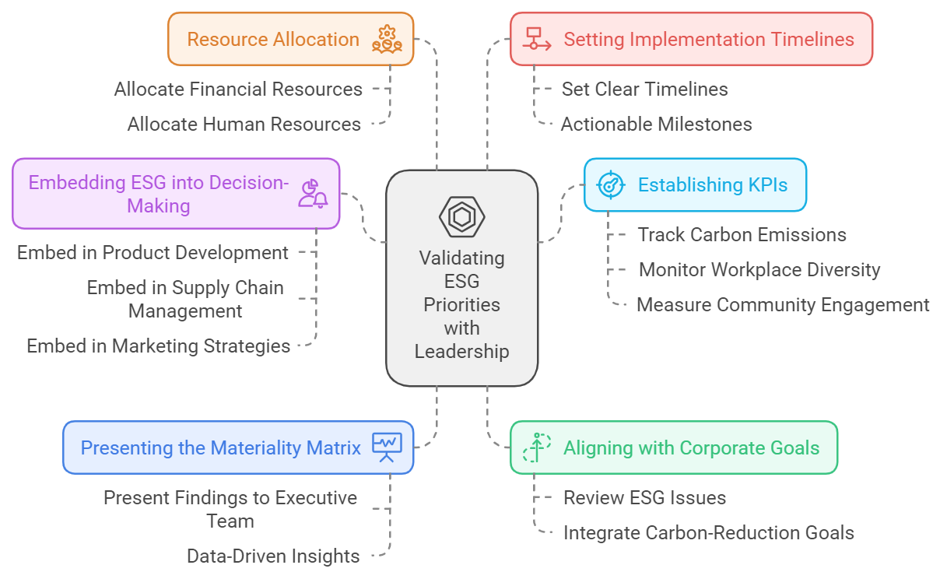

Real-World Example: Leadership Validation in the Technology Sector
For a technology company, let’s say the materiality assessment identifies data privacy and employee diversity as top ESG issues. In the validation process, leadership would:
- Review the importance of data privacy in relation to customer trust and regulatory requirements, deciding to invest in better security protocols.
- Prioritize diversity, agreeing to allocate resources to improve hiring practices and establish more robust employee resource groups (ERGs).
- Set KPIs to track improvements in both areas over time and integrate these priorities into core business functions like product development and recruitment.
Now that we have examined how to identify and prioritise the most relevant ESG issues, it is essential to broaden our perspective. This means considering not only how these issues affect our business, but also how our actions influence the external environment—a concept known as double materiality.

4.4 Double Materiality: Looking Beyond Financial Impacts
Double materiality is an approach that broadens the traditional concept of financial materiality by considering both the effects of environmental, social and governance (ESG) issues on a company, and the impact the company itself has on the environment and society. In other words, it involves assessing material issues from two distinct perspectives:
Financial Materiality ("Outside-In"): This perspective examines how external ESG factors affect the company’s financial health. It includes evaluating how climate change, resource scarcity, regulatory pressures, and other ESG-related risks and opportunities influence the company’s performance and profitability.

Impact Materiality ("Inside-Out"): This perspective focuses on the company’s operations and activities, and how these affect society and the environment. This might include carbon emissions, impacts on local communities, labour practices, and contributions to biodiversity loss.
Definition Box:
- Outside-In: Refers to financial materiality, meaning how external ESG factors impact the company’s financial performance.
- Inside-Out: Refers to impact materiality, meaning how the company’s activities affect the external environment and society.

Double materiality requires companies to assess and disclose both the financial impact of ESG factors on their business ("outside-in") and the impact of their activities on society and the environment ("inside-out"). This dual approach is becoming increasingly important to stakeholders and regulators alike, as it offers a more holistic understanding of a company’s sustainability impact.
Example: Mining Industry
Financial Materiality ("Outside-In") :A mining company may face financial risks from regulatory changes related to carbon emissions, which could increase operational costs.
Impact Materiality ("Inside-Out") : The same company may also be significantly impacting local biodiversity, as its mining operations disrupt local ecosystems. In this case, double materiality would demand that the company address not only the financial implications of emissions regulation but also its environmental responsibility for biodiversity protection
Example: Pharmaceutical Industry
Financial Materiality ("Outside-In"): A pharmaceutical company may face financial risks arising from stricter regulations on emissions or increasing demands for energy efficiency. Such changes could result in higher production costs and necessitate enhanced compliance measures.
Impact Materiality ("Inside-Out"): Conversely, the pharmaceutical company may significantly affect community health through chemical runoff from its production facilities, potentially compromising local water quality and public health. This dimension of impact materiality underscores the company’s broader social and environmental responsibilities beyond its financial obligations.
Why Double Materiality Matters:
Considers Both Internal and External Impacts By addressing both "Outside-In" and "Inside-Out" perspectives, double materiality ensures that companies are aware of the risks they face from external ESG factors, as well as the impacts they have on their environment and communities.
Improves Accountability and Transparency: Regulators and stakeholders increasingly expect companies to disclose comprehensive information on both types of materiality. This ensures that businesses are held accountable not only for their financial risks but also for their environmental and social footprint.
Aligns with Global Regulatory Expectations: In the European Union, regulatory frameworks such as the Corporate Sustainability Reporting Directive (CSRD) require companies to disclose information on both financial and impact materiality. This reflects the growing importance of a dual approach to materiality and helps companies align with global expectations on sustainability disclosures.
Key Takeaways: Double Materiality ("Outside-In" and "Inside-Out")
- Double materiality provides a comprehensive framework for understanding and managing ESG issues from both a financial and societal/environmental perspective.
- "Outside-In" refers to the financial risks or benefits that external ESG factors pose to the company.
- "Inside-Out" refers to the social and environmental impacts that a company's activities have on the world around it.
- Companies need to address both perspectives to meet stakeholder expectations and comply with emerging regulatory requirements.

4.5 Analyzing and Ranking ESG Issues with Surveys
Once the double materiality approach is integrated, surveys can be used to gather quantitative data to analyse and rank ESG issues. This method helps companies to understand the significance of different ESG topics across stakeholder groups.
Steps to Analyze and Rank ESG Issues :
  - Design a Comprehensive Survey
Create a survey that includes a range of ESG topics, tailored to your industry. Ask stakeholders to rank each topic on a scale of 1 to 5 (1 being the lowest importance, 5 the highest). Use clear, simple language to improve understanding and ensure all respondents can participate fully.
2. Leverage Advanced Survey Software for Analytics
Advanced survey tools such as Qualtrics, SurveyMonkey Enterprise, or Google Forms can make the ranking process more efficient. These platforms offer features like data visualisation and basic predictive insights. Here’s how they can help:
- Identify Patterns:
Use analytics to quickly identify which issues are most important to different stakeholder groups.
Example: If employees in a particular region consistently rank "workplace safety" as their top priority, this can inform targeted safety initiatives in that region.
- Predictive Insights:
Some software can suggest how improvements in one ESG area may impact others.
Example: Data might show that enhanced waste management is linked to increased customer satisfaction, providing insight into where to focus your efforts.
- Prioritizing ESG Issues with Confidence:
Advanced software enables accurate ranking of ESG issues by quantifying stakeholder preferences.
Example: If a majority of investors prioritise "carbon reduction", you can be confident that focusing on reducing emissions aligns with their interests.
These features allow organisations to prioritise ESG matters based on reliable, data-driven insights.
- Quantify Results
Analyse the survey data to identify which issues matter most. Rank these issues in your materiality matrix for ease of reference.
Example: A retail company may find that its customers value "ethical sourcing" and "reducing plastic waste" above all. This analysis helps direct resources where they will have the most impact.

- Visualize Findings
Use tools that support the easy creation of visual reports and dashboards. This helps communicate results clearly to decision-makers.
Example: Platforms like Tableau or Power BI can generate visual summaries, showing how each stakeholder group ranks different ESG priorities—ensuring insights are both actionable and easy to present.

4.6 Case Study: Materiality Assessment in the Aviation Industry
Let us examine a detailed case study of an aviation company conducting a materiality assessment. This example illustrates how the significance of various ESG topics can differ depending on the country or region in which the company operates, as well as regulatory pressures and stakeholder expectations.
Aviation Companies in Different Regions
- Aviation Company A (North America)
  - A large, global airline based in the United States.
  - Operates in a highly regulated environment, particularly regarding environmental emissions and labor practices.
  - High exposure to climate risk due to frequent long-haul international flights.
- Aviation Company B (Europe)
  - A mid-sized airline based in France.
  - Operates under strict European Union climate regulations (e.g., EU ETS - Emissions Trading System).
  - Faces strong stakeholder pressure from consumers and governments to adopt sustainability practices.

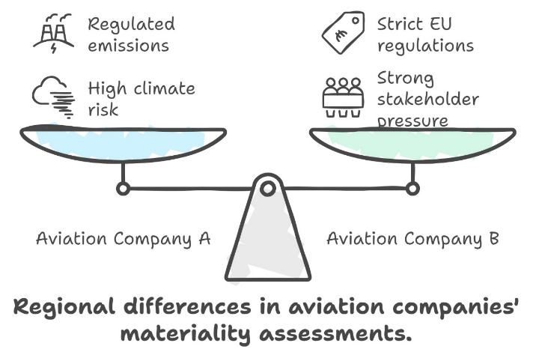

Step 1: Identify 50 ESG Topics
We begin by listing 50 potential ESG topics relevant to the aviation industry, which will later be prioritised for each of the two companies. These topics span environmental, social, and governance issues.

Step 2: Analyze and Prioritize ESG Topics for Each Company
We will now analyse and prioritise these 50 ESG topics for each aviation company, based on regional regulations, stakeholder pressures, and company-specific challenges. This step involves ranking the issues within a Materiality Matrix for each company.

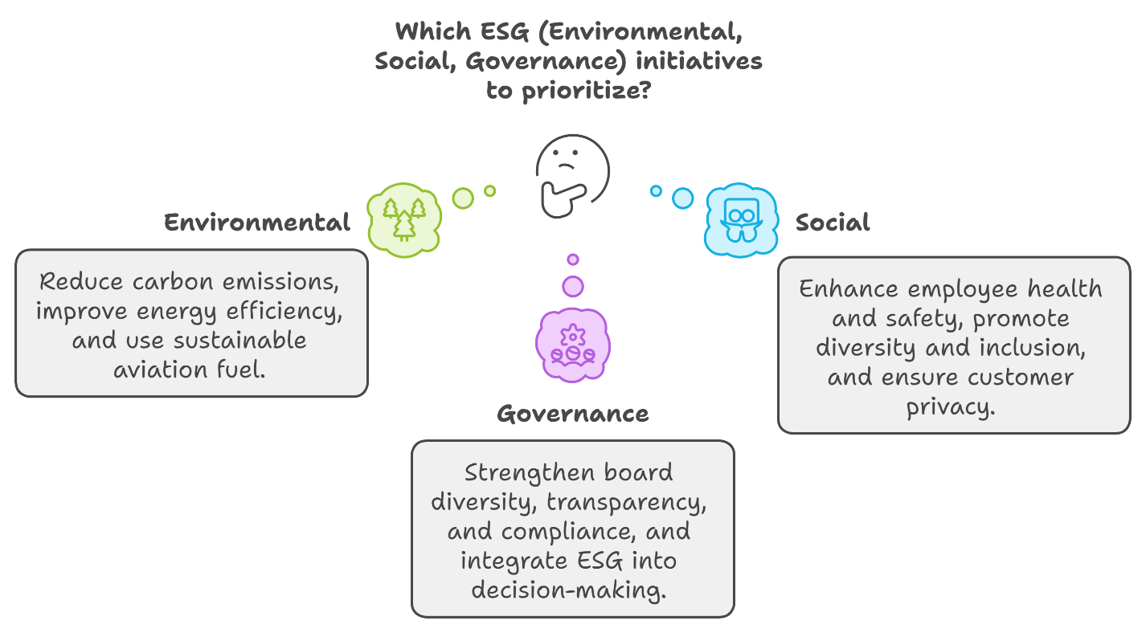

Aviation Company A (North America)
Environmental Focus:
- Top Priorities: Carbon emissions (1), use of sustainable aviation fuel (3), and climate adaptation (7).
  - These are crucial due to increasing EPA regulations and scrutiny from both regulators and the public.
- Medium Priorities: Noise pollution (4) and GHG reporting (13), as the company operates around airports with strict noise regulations.
Social Focus:
- Top Priorities: Employee health and safety (16), diversity and inclusion (18), and labor rights (21), driven by both regulatory and stakeholder demands.
  - The airline is under pressure to ensure fair labor practices and improve diversity in its workforce.
Governance Focus:
- Top Priorities: Board diversity (31), executive compensation linked to ESG performance (32), and anti-corruption measures (33).
  - These are critical to maintaining investor confidence and meeting U.S. governance standards.
Low-Priority Topics:
- Water consumption (5) and biodiversity impacts (8) are less material for this company, as these issues are less significant within its operational context.
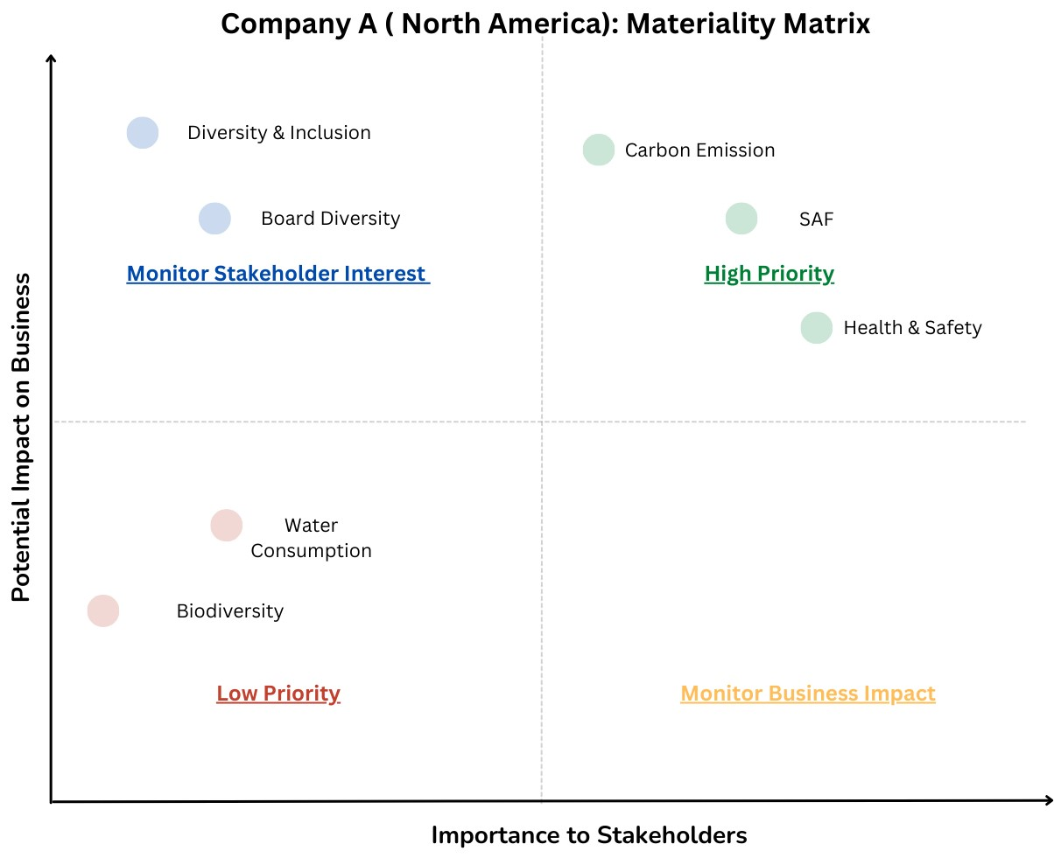

Aviation Company B (Europe)
Environmental Focus:
- Top Priorities: Carbon emissions (1), sustainable aviation fuels (3), and GHG transparency (13).
  - The EU ETS requires rigorous tracking of carbon emissions and fuel efficiency, making these issues central to the company’s strategy.
- Medium Priorities: Noise pollution (4) and air quality (9), driven by community concerns around major airports.
Social Focus:
- Top Priorities: Labor rights (17) and diversity (18), aligning with strict EU labor regulations.
  - Community engagement (23) is also crucial, particularly for European expansion projects where local stakeholders demand accountability.
Governance Focus:
- Top Priorities: Transparent ESG reporting (38) and board independence (31).
  - European investors require full disclosure of the company’s ESG performance, as mandated by EU regulations.
Low-Priority Topics:
- Customer data privacy (29) may be less of a concern here, given the robust protections already provided under GDPR regulations.
- 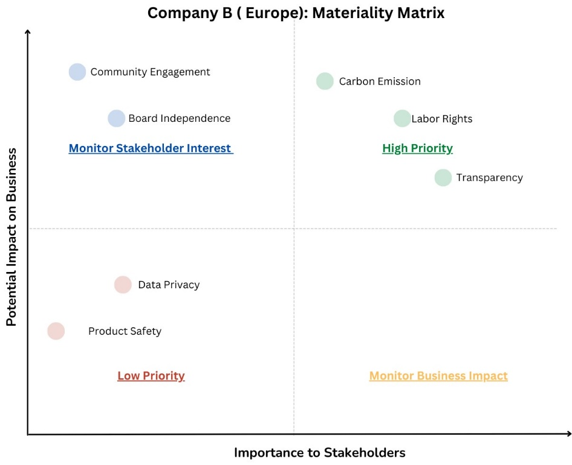

Step 4: Engaging Stakeholders for ESG Alignment
For each company, stakeholder engagement is a crucial part of aligning ESG priorities with both regulatory compliance and corporate objectives. Here is how each aviation company engages with its stakeholders:
- Aviation Company A (North America):
  - Investor Engagement: Investors are increasingly calling for greater transparency regarding carbon emissions and diversity practices. The company conducts surveys and one-to-one interviews with institutional investors to gather feedback.
  - Customer Surveys: To assess the impact of carbon emissions on customer loyalty, the company surveys frequent flyers to understand their preferences regarding sustainable aviation.
- Aviation Company B (Europe):
  - Community Forums: Engages with local communities surrounding major European airports through public forums and town hall meetings, focusing on noise pollution, job creation, and community well-being.
  - Labor Union Discussions: Regular dialogues with labor unions to ensure fair labor practices and improve workplace diversity and inclusion.
Conclusion: Aligning ESG Strategy with Risks and Corporate Goals
By conducting a detailed materiality assessment and carefully prioritising ESG topics, each aviation company ensures that its sustainability strategy is fully aligned with regulatory requirements, stakeholder expectations, and corporate objectives. This alignment not only mitigates risks but also enhances the company’s competitive advantage, operational resilience, and long-term value creation. The ability to tailor ESG priorities to regional, regulatory, and industry-specific challenges is what drives success in today’s complex and rapidly evolving business environment.

Step 5: Implementing and Monitoring ESG Strategies
Each company needs to ensure that the material ESG issues are not just identified but acted upon, with clear monitoring mechanisms in place. Here’s how each company approaches implementation:
- Aviation Company A (North America):
  - Action Plan: Develops an emissions reduction plan that includes the use of sustainable aviation fuel (SAF) and energy-efficient aircraft. The company introduces diversity training programs and sets quotas for improving gender and ethnic representation in leadership roles.
  - Monitoring and Reporting: Reports on ESG progress in its annual report and implements quarterly reviews to track emissions and diversity KPIs.
- Aviation Company B (Europe):
  - Action Plan: Invests in renewable energy projects, including solar power at major airports, and enhances community engagement programs.
  - Monitoring and Reporting: Implements a real-time carbon tracking system to meet EU ETS reporting requirements and conducts annual community satisfaction surveys.
- Aviation Company C (Middle East):
  - Action Plan: Focuses on reducing water consumption through recycling initiatives and improving labor conditions by working with third-party auditors to ensure compliance with international standards.
  - Monitoring and Reporting: Monitors water usage through smart metering technologies and reports labor rights improvements through sustainability reports shared with international stakeholders

Future Outlook for ESG Strategy
Each aviation company must also consider how its ESG strategy will evolve in the future, taking into account emerging regulations and shifting stakeholder expectations.
- Aviation Company A (North America):
  - Future Trends: Anticipates stricter U.S. regulations around carbon emissions and workplace diversity. The company plans to adopt electric aircraft technologies within the next decade to further reduce emissions.
- Aviation Company B (Europe):
  - Future Trends: As European stakeholders increasingly prioritize biodiversity and supply chain transparency, the company is exploring ways to integrate more biodiversity-friendly airport expansions and fair trade sourcing into its strategy.

4.5 Conclusion: Aligning ESG Strategy with Risks and Corporate Goals
By conducting detailed materiality assessments and carefully prioritising ESG topics, each aviation company can ensure that its sustainability strategy is fully aligned with regulatory requirements, stakeholder expectations, and corporate goals. This alignment not only mitigates risks but also enhances the company’s competitive advantage, operational resilience, and long-term value creation.
Key Takeaways:
- Materiality assessments help companies identify the most critical ESG issues for their business and stakeholders.
- Leadership validation and resource allocation ensure that identified ESG priorities are integrated into long-term corporate strategy.
- Stakeholder engagement and continuous monitoring are crucial for maintaining transparency and accountability in ESG practices.
Aligning materiality outcomes with a company’s ESG strategy helps ensure that identified risks and opportunities are seamlessly integrated into business operations, resulting in more effective resource allocation and stakeholder engagement.
This case study demonstrates how companies can tailor their ESG strategies to regional challenges, industry regulations, and stakeholder expectations, thereby ensuring a sustainable and competitive future in a rapidly evolving business environment.

5 Developing the Strategy and the Roadmap
5.1 Transitioning from Materiality to Strategy
You’ve done the groundwork—the materiality assessment has identified the key Environmental, Social, and Governance (ESG) issues most significant to your company and stakeholders. Now it’s time to turn these insights into an actionable strategy that propels your business forward.
This is the stage where your company moves from understanding what matters to implementing meaningful change. The process is not just about addressing ESG issues individually—it is about embedding these considerations into the fabric of your business, thereby driving long-term value, operational efficiency, and stakeholder trust.
By the end of this chapter, you'll be able to:
- Define your company’s ESG vision and goals
- Set clear, measurable objectives
- Build a step-by-step roadmap for implementation
- Make sure everything lines up with both your internal priorities and what stakeholders are looking for

Let's dive into how to take these steps and transform materiality assessments into a powerful strategy.
5.1.1 Defining Your ESG Vision and Mission
Vision: Crafting Your North Star for Sustainability
The ESG Vision serves as your organisation’s north star. It should reflect where your company aspires to be in terms of sustainability over the next 10, 20, or even 50 years. It must be bold, inspiring, and clear enough to convey your company’s long-term intent to both internal and external stakeholders.

Key Characteristics of an Effective ESG Vision:
- Aspirational: Your vision should be ambitious, reflecting your desire to be a leader in ESG performance.
  - Example: "To lead the renewable energy industry in zero-emission operations, becoming a catalyst for sustainable development globally by 2040."
- Broad and Long-Term: The vision should describe the destination, not the individual steps.
- Stakeholder-Oriented: It should demonstrate a positive impact not only on shareholders but also on a broader range of stakeholders — including communities, the environment, and society at large.
Case Study: Patagonia, the outdoor apparel brand, has crafted a vision centred on environmental activism: "We're in business to save our home planet." This simple yet powerful statement guides every business decision, clearly articulating what Patagonia stands for and the depth of its commitment to sustainability.
Mission: Connecting Vision to Action
While the vision looks far into the future, the ESG mission defines the "how". It is a focused, actionable set of steps that outlines how the company intends to achieve its ESG vision. The mission should be both motivational and practical, serving to guide employees and align with strategic goals.
Key Characteristics of an Effective ESG Mission:
- Action-Oriented: Focus on how to translate the aspirational goals of your vision into specific actions.
  - Example: "To reduce carbon emissions by 60% by 2030 through investments in renewable energy, sustainable product design, and community-driven initiatives."
- Time-Bound: The mission should be more specific and time-bound than the vision, offering clear timelines for action.
- Aligned with Business Strategy: Ensure the mission aligns with broader corporate objectives, integrating ESG as a core element of business growth.

Toolkit: Vision and Mission Development Checklist
- Step 1: Assemble a diverse cross-functional team to provide insights from different aspects of the business.
- Step 2: Host a vision-setting workshop to define where the company wants to be in 10-20 years in the sustainability space.
- Step 3: Translate the vision into actionable mission goals that detail how to achieve those aspirations.
- Step 4: Review and iterate until both are aligned with corporate values and stakeholder expectations.

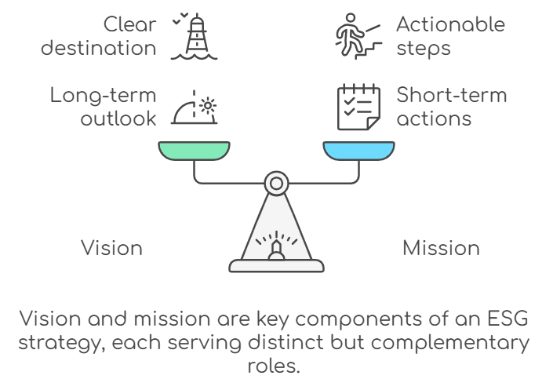
5.2 Establishing Strategic ESG Pillars
What Are Strategic ESG Pillars?
Strategic ESG pillars are the core areas of focus that align with your company’s ESG vision and mission. These pillars form the foundation for your goals, key initiatives, and performance indicators. Depending on your industry and the material issues identified, your ESG pillars will vary; however, they should be broad enough to encompass the full spectrum of your company’s sustainability objectives.

Common ESG Pillars Include:
- Climate Action and Environmental Stewardship:
  - Focus: Reduce carbon emissions, optimize energy use, improve waste management.
  - Example: A technology company aiming to operate all facilities using renewable energy by 2035.
- Social Responsibility and Workforce Well-being:
  - Focus: Enhance employee diversity, equity and inclusion (DEI); support employee well-being and foster community engagement.
  - Example: A mid-sized healthcare provider focused on improving staff mental health programs and community healthcare outreach.
- Governance and Ethical Leadership:
  - Focus: Ensure ethical business practices, compliance, and stakeholder accountability.
  - Example: A financial services company adopting enhanced transparency standards and linking executive pay to ESG targets.
4. Innovation and Sustainable Solutions:
- Focus: Drive technological and process innovations to develop sustainable products, services, and business models that support environmental, social, and governance objectives. Innovation is essential for adapting to the evolving sustainability landscape and generating long-term value.
- Example:
  - Technology Industry: A software company developing AI-based tools to improve energy efficiency in data centers and reduce emissions.
  - Manufacturing: A manufacturer investing in research to create biodegradable packaging solutions and reduce reliance on plastics.
Why Innovation Should Be an ESG Pillar
Transitioning from the materiality assessment, it is crucial to recognise that achieving sustainability goals goes beyond current practices—it is about innovating for a future in which new solutions are continually developed and refined. Positioning Innovation as a strategic ESG pillar empowers your company to actively drive change rather than merely respond to it. Here is why innovation is central to ESG:
- Supports Climate Goals: Innovation enables the development of new technologies that reduce environmental impact, such as carbon capture, renewable energy systems, and circular economy solutions.
- Advances Social Outcomes: Innovative approaches can enhance workplace environments (e.g., using AI for improved DEI analytics) and increase product accessibility for underserved communities.
- Improves Governance: Technological advances such as blockchain and AI-driven compliance tools can enhance transparency, reduce fraud, and support ethical governance practices.
- Drives Competitiveness: Companies that prioritise innovation can create distinctive solutions, respond effectively to stakeholder demands, and unlock new business opportunities.
Toolkit: Innovation Strategy for ESG Success
- Step 1: Identify key areas for innovation—such as product development, process improvements, or operational efficiency—that align with ESG goals.
- Step 2: Allocate resources for R&D that focus specifically on ESG innovations, whether through internal development or partnerships with startups and research institutions.
- Step 3: Set targets for introducing innovative solutions, such as creating a product line with fully sustainable materials by 2027 or developing software that supports social impact metrics.
Adding Innovation as a strategic ESG pillar allows companies to focus not just on compliance and current best practices but also on actively pushing boundaries to develop new ways to solve sustainability challenges. It positions companies to lead rather than follow, transforming sustainability into a growth and value creation opportunity.
How to define Strategic Pillars:
- Identify Material Issues: Use your materiality assessment to pinpoint issues most relevant to your stakeholders.
- Align with Business Strategy: Ensure the pillars resonate with core business activities and competitive priorities.
- Set Broad Themes: Strategic pillars should be broad enough to encompass a wide range of initiatives while being specific to address key challenges.
Case Study: Unilever developed three main pillars: improving health and well-being, reducing environmental impact, and enhancing livelihoods. Each pillar represents a core sustainability goal that aligns with the company’s corporate mission and resonates with stakeholders globally.

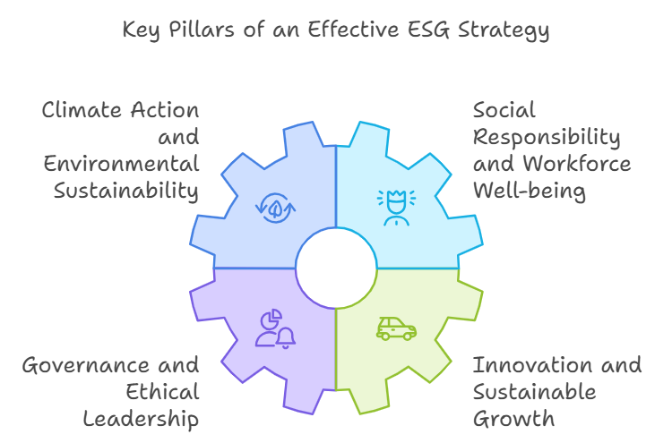

5.3 Setting ESG Goals and Targets
5.3 Setting ESG Goals and Targets
SMART Goals: Bringing Strategy to Life
After defining your vision, mission, and strategic pillars, the next step is to establish specific goals that are SMART — Specific, Measurable, Achievable, Relevant, and Time-bound. SMART goals provide clear direction, ensure alignment, and enable effective measurement, helping you track progress over time.
5.3.1 SMART Goals for ESG
To ensure that ESG goals are actionable and measurable, they should adhere to the SMART framework:
- Specific Goals: Clearly define what needs to be achieved.
Example: Reduce Scope 1 and Scope 2 greenhouse gas emissions by 50% by 2028.
- Measurable Goals: Include criteria to measure progress.
Example: Increase renewable energy usage from 25% to 75% in all manufacturing plants by 2027.
- Achievable Goals: Set realistic goals that can be met within the company’s capacity.
Tip: Assess the current baseline. If renewable energy usage is at 10%, aiming for 30-40% in two years is ambitious but realistic.
- Relevant Goals: Ensure the goals align with the company’s broader objectives and material ESG issues.
Example: If reducing plastic waste is part of your ESG strategy, ensure it’s relevant to the product lifecycle and customer demands.
- Time-bound Goals: Assign a timeline for achieving the goals.
Example: Eliminate single-use plastics across all facilities by December 2026.
To make SMART goals actionable:
- Use KPIs to track progress.
- Develop milestones for long-term goals to maintain focus and show incremental progress.
- Assign ownership to ensure accountability at every level.
5.4 Developing the ESG Roadmap
Turning Strategy into Action: Building the ESG Roadmap
With goals in place, the next step is to develop a roadmap that translates these strategic aspirations into a detailed, actionable plan. This roadmap will offer a structured approach to achieving ESG goals, outlining timelines, milestones, responsibilities, and the resources required.
Steps to Develop the ESG Roadmap:
- Define Short-, Medium-, and Long-Term Goals:
  - Short-Term Goals (0-2 years): Quick wins that are easy to implement, such as energy efficiency audits.
  - Medium-Term Goals (3-5 years): Scaling successful pilots or implementing renewable energy solutions across facilities.
  - Long-Term Goals (5+ years): Larger aspirations such as achieving net-zero emissions.
- Assign Responsibilities:
  - Designate ESG champions for each goal who are responsible for leading the initiatives and maintaining accountability.
- Allocate Resources:
  - Determine the financial, technological, and human resources needed for each goal.
- Set Milestones and Track Progress:
  - Establish clear milestones to be reached at different points.
  - Track progress using regular performance reviews and stakeholder updates.
Example: ESG Roadmap for GreenTech Manufacturing:
- Short-Term: Conduct energy audits and set up carbon baselines.
- Medium-Term: Implement renewable energy solutions in 50% of operations.
- Long-Term: Achieve full carbon neutrality by 2040, with progress checkpoints every five years.

Conclusion: Creating a Cohesive ESG Strategy
Developing an ESG strategy is an ongoing process that starts with understanding material issues and ends with a concrete plan of action. By:
- Defining an aspirational vision and mission,
- Establishing strategic pillars to focus your efforts,
- Setting SMART goals to provide measurable direction, and
- Building a roadmap that outlines step-by-step implementation,
you will create a comprehensive ESG strategy that drives meaningful change. This chapter has provided the structured approach to move from aspiration to action, allowing your business to embrace sustainability in a way that aligns with its goals and meets stakeholder expectations.
In the appendix, you’ll find tools, templates, and KPIs to support the successful implementation of your ESG strategy, making this a practical guide for your sustainability journey.

Appendices
Stakeholder Engagement Checklist
[Downloadable Stakeholder Engagement Checklist]
- Identify Key Stakeholders:
  - Create a list of internal stakeholders (e.g., employees, management, board members).
  - Create a list of external stakeholders (e.g., investors, suppliers, customers, NGOs, local communities).
  - Map stakeholders based on influence and interest in your ESG activities.
- Determine Stakeholder Expectations:
  - Conduct surveys, interviews, or focus groups to understand stakeholder concerns.
  - Identify ESG topics that are most important to each stakeholder group.
  - Analyze and prioritize stakeholder expectations.
- Develop Engagement Plan:
  - Develop tailored communication strategies for each stakeholder group.
  - Determine frequency and method of communication (e.g., quarterly reports, town halls, social media updates).
  - Establish feedback mechanisms (e.g., online feedback forms, regular meetings).
- Set Clear Objectives:
  - Define specific engagement goals (e.g., increase investor awareness of ESG strategy).
  - Align engagement objectives with ESG goals (e.g., promote sustainable sourcing with suppliers).
- Assign Roles and Responsibilities:
  - Designate a point of contact for each stakeholder group.
  - Assign team members to handle various aspects of stakeholder engagement (e.g., communications, data collection, follow-up).
- Monitor Engagement Outcomes:
  - Track stakeholder feedback and its impact on ESG strategy.
  - Regularly review engagement outcomes to ensure objectives are being met.
  - Adjust the stakeholder engagement plan based on new insights or feedback.

4. ESG Risk Assessment Template
[Downloadable ESG Risk Assessment Template]
Risk Category | Risk Description | Likelihood | Impact | Mitigation Strategy | Owner | Status
Environmental | Climate change impacts on supply chain | High | High | Diversify suppliers in less vulnerable regions | Supply Chain Manager | In Progress
Social | Labor strikes due to working conditions | Medium | Medium | Improve worker conditions and offer competitive benefits | HR Manager | Not Started
Governance | Failure to comply with new ESG regulations | High | High | Hire external consultants to audit compliance | Compliance Officer | In Progress
Reputation | Negative media coverage on ESG practices | Medium | High | Develop a crisis management plan and improve transparency | PR Manager | Ongoing
Instructions:
- Use this template to assess ESG risks across environmental, social, and governance categories.
- Regularly update the “Likelihood” and “Impact” ratings based on new data.
- Include mitigation strategies to minimize potential risks.
5. ESG Communication Plan Template
[Downloadable ESG Communication Plan Template]
Internal Communication:
- Objective: Ensure all employees understand the ESG strategy and their role in its success.
- Audience: Employees, department heads, leadership.
- Channels:
  - Monthly newsletter.
  - Intranet updates.
  - Town hall meetings.
  - ESG training workshops.
- Frequency: Monthly, quarterly.
External Communication:
- Objective: Share ESG progress with external stakeholders, including investors, customers, and the public.
- Audience: Investors, customers, suppliers, media.
- Channels:
  - Annual ESG report.
  - Investor roadshows.
  - Press releases.
  - Social media updates.
- Frequency: Annually (for report), quarterly (for updates).
Key Messages:
- Highlight major ESG achievements (e.g., reduction in carbon emissions, diversity improvements).
- Communicate future goals and targets.
- Address any challenges or setbacks transparently.
Checklist for Communication Plan:
- Does your message align with the company’s overall ESG vision?
- Are you using the right communication channels for your audience?
- Is your communication transparent, consistent, and supported by data?

• Alignment with Company’s ESG Vision:
- Does your communication align with the overall ESG mission and vision?
- Are you highlighting the most material issues identified in your ESG strategy?
• Channel Selection:
- Are you using the right channels for each audience (e.g., intranet for employees, social media for customers)?
- Have you considered both internal and external stakeholders in your plan?
• Consistency and Transparency:
- Are your ESG communications consistent across all platforms?
- Are you transparent about both achievements and areas for improvement?
• Data-Driven Messaging:
- Is your communication supported by accurate and up-to-date ESG data?
- Are you using clear, easy-to-understand metrics and visuals?
• Engagement and Feedback:
- Are you providing opportunities for stakeholders to ask questions and provide feedback?
- Have you established a feedback loop to improve future communications?

CHAPTER 2 – risk assessment and CSA

1. Stakeholder Engagement Survey Template
Introduction: This survey template is customizable and designed to help companies understand the perspectives of their stakeholders—including employees, suppliers, customers, and community members—on critical ESG (Environmental, Social, and Governance) issues. The questions below are designed to be a starting point that can be tailored to fit specific industries or organizational needs. The responses collected will help shape your ESG strategy by identifying key areas of concern and opportunities for improvement.
Survey Questions:
Employee Section:
- How aware are you of the company’s environmental initiatives?
  - Not aware at all / Slightly aware / Moderately aware / Very aware / Extremely aware
- How satisfied are you with the company’s commitment to diversity and inclusion?
  - Very dissatisfied / Dissatisfied / Neutral / Satisfied / Very satisfied
- Do you believe the company supports employee well-being (work-life balance, mental health support, etc.)?
  - Strongly disagree / Disagree / Neutral / Agree / Strongly agree
- How often do you participate in the company’s sustainability initiatives (e.g., recycling programs, energy-saving measures)?
  - Never / Rarely / Occasionally / Frequently / Always
- How can the company improve its environmental efforts at the workplace? (Open-ended)
Supplier Section:
- How would you rate our company’s communication regarding ESG expectations?
  - Poor / Fair / Good / Very good / Excellent
- To what extent are you willing to collaborate to improve our shared environmental footprint?
  - Not willing at all / Somewhat willing / Neutral / Willing / Extremely willing
- Do you have any suggestions for improving sustainability in our supply chain? (Open-ended)
Customer Section:
- How important is a company’s sustainability performance to your purchasing decision?
  - Not important at all / Slightly important / Moderately important / Very important / Extremely important
- How satisfied are you with the transparency of our environmental practices?
  - Very dissatisfied / Dissatisfied / Neutral / Satisfied / Very satisfied
Community Section:
- How do you perceive our company’s impact on the local community?
  - Very negative / Somewhat negative / Neutral / Somewhat positive / Very positive
- What areas of community engagement could we improve? (Open-ended)
Metrics for Analysis:
- Use Likert Scale Evaluations to quantify responses, enabling a numerical analysis of satisfaction and awareness levels.
- Open-ended responses can be categorized for qualitative insights, helping identify recurring themes and ideas.
2. Stakeholder Mapping Checklist
Introduction: The Stakeholder Mapping Checklist is designed to help companies identify key stakeholders involved in or affected by ESG efforts. This checklist can be used to determine the influence, interest, and impact of various stakeholders on your company's ESG strategy. Use this tool to ensure that all voices are considered when building or refining your ESG plan.
Stakeholder Mapping Checklist:
- Identify Stakeholders:
  - List all relevant stakeholders.
    - Internal: Employees, Board members, Shareholders.
    - External: Customers, Suppliers, Regulators, Community Groups, NGOs.
- Determine Stakeholder Attributes:
  - Power: Does this stakeholder have decision-making power over ESG initiatives?
  - Interest: Is this stakeholder highly interested in the outcomes of ESG policies?
  - Impact: How much will the ESG strategy impact this stakeholder?
- Evaluate Stakeholder Influence:
  - Does the stakeholder have a high or low influence on ESG goals?
  - Can this stakeholder significantly support or hinder ESG progress?
- Prioritize Stakeholders:
  - Based on power, interest, and impact, assign each stakeholder to one of the following categories:
    - High Power, High Interest: Engage closely and keep informed.
    - High Power, Low Interest: Keep satisfied but don’t overload with details.
    - Low Power, High Interest: Keep informed and involve as needed.
    - Low Power, Low Interest: Monitor with minimal engagement.

Stakeholder Mapping Table
Stakeholder Name | Power Level (High/Low) | Interest Level (High/Low) | Impact Level (High/Low) | Influence on ESG Goals (High/Low) | Engagement Strategy
Employees | High | High | High | High | Engage closely and keep informed
Board Members | High | Low | High | High | Keep satisfied; provide relevant updates
Shareholders | High | Low | Medium | High | Keep satisfied, focus on key performance
Customers | Low | High | High | Medium | Keep informed and involve in campaigns
Suppliers | Medium | Medium | High | Medium | Engage collaboratively to meet standards
Regulators | High | High | High | High | Engage closely, ensure compliance
Community Groups | Low | High | Medium | Medium | Keep informed, gather feedback
NGOs | Low | High | Low | Medium | Keep informed, involve when necessary
Local Government | High | Medium | High | High | Engage closely, ensure legal alignment
Media | Low | High | Medium | Low | Monitor and engage when required

3. Stakeholder Matrix Template
Introduction: The Stakeholder Matrix Template helps categorize stakeholders based on their power, influence, and interest in your company's ESG initiatives. Use this visual tool to strategically manage stakeholder relationships and plan engagement tactics.
Stakeholder Matrix:
Stakeholder Name | Power Level (High/Low) | Interest Level (High/Low) | Engagement Strategy
Employees | High | High | Engage closely and empower
Shareholders | High | Low | Keep satisfied
Community Groups | Low | High | Keep informed
Regulatory Bodies | High | High | Engage closely and collaborate
NGOs | Low | Low | Monitor
- Legend:
  - High Power, High Interest: Collaborate actively and maintain continuous communication.
  - High Power, Low Interest: Regular updates, emphasize strategic importance.
  - Low Power, High Interest: Provide opportunities for involvement; keep informed.
  - Low Power, Low Interest: Keep updated with general communication.
Compliance Checklist
Introduction:
This Compliance Checklist ensures that companies maintain compliance with all relevant local and international ESG regulations. This checklist covers environmental laws, social standards, and corporate governance requirements, helping verify that your ESG practices are aligned with best practices and regulatory standards.

1. Environmental Compliance
1.1 Local and International Standards Compliance
- Local Environmental Standards: Verify adherence to waste management regulations, emissions standards, and pollution limits as per national laws.
  - Document reference: Attach records of permits, certificates, and approved environmental plans.
- International Agreements: Ensure compliance with agreements like the Paris Agreement or UN Sustainable Development Goals (SDGs).
  - Have emission reduction goals that align with Paris Climate Goals.
  - Participate in regional or global climate initiatives where applicable.
1.2 Pollution and Emissions Reporting
- Emissions Tracking: Track and report:
  - Scope 1: Direct emissions from company-owned sources.
  - Scope 2: Indirect emissions from energy purchased and used by the company.
  - Scope 3: Emissions across the value chain, including suppliers, transportation, and product end-use.
  - Document Reference: Provide an annual emissions report with verification by third-party auditors.
- Reduction Targets:
  - Set and publish annual targets for reducing carbon emissions, air pollution, and water contamination.
  - Monitor progress against Science-Based Targets (SBTi), where applicable.
1.3 Waste and Resource Management
- Hazardous Waste Management: Adhere to regulations regarding the disposal and handling of hazardous materials.
  - Document methods of waste disposal and ensure they are certified by authorities.
- Water Management:
  - Track water usage and wastewater output.
  - Ensure compliance with local water treatment standards.
  - Develop a plan to reduce water usage by a set percentage over a defined period.
- Circular Economy Initiatives:
  - Establish initiatives to reuse, recycle, or reduce materials used in operations.
  - Maintain documentation for waste diverted from landfills or products recycled.
1.4 Biodiversity and Habitat Conservation
- Biodiversity Assessments: Conduct assessments before major projects to measure impact on local ecosystems.
  - Obtain certifications or approvals from environmental agencies.
- Conservation Efforts:
  - Engage in conservation projects or partnerships to offset environmental impacts.
  - Record partnerships with conservation organizations and ensure consistent tracking.

2. Social Compliance
2.1 Labor Standards and Human Rights
- Local Labor Law Compliance:
  - Adhere to minimum wage laws, working hours, and occupational health and safety standards.
  - Provide records of employee contracts to ensure they align with local legal standards.
- Global Standards:
  - Align with the ILO (International Labour Organization) standards.
  - Implement a Zero Tolerance Policy for forced labor or child labor.
  - Conduct audits within the supply chain to ensure suppliers are compliant with labor laws.
2.2 Workplace Health and Safety
- Safety Protocols:
  - Implement and update Occupational Health and Safety programs.
  - Conduct regular safety training sessions for all employees.
  - Keep an updated incident reporting log and safety audit records.
- Certification:
  - Maintain ISO 45001 certification for occupational health and safety.
2.3 Diversity, Equity, and Inclusion (DEI)
- Anti-Discrimination Policies:
  - Develop and publicize anti-discrimination policies covering hiring, promotion, and workplace behavior.
  - Record any employee grievances and actions taken to address them.
- Diversity Programs:
  - Set and track goals for gender and ethnic diversity at all company levels.
  - Conduct regular diversity and inclusion training.
2.4 Community Impact and Stakeholder Engagement
- Community Engagement Programs:
  - Develop and implement community support initiatives (e.g., educational programs, local employment initiatives).
  - Track impact metrics, such as the number of community members reached or supported.
- Stakeholder Communication:
  - Engage with local communities before starting major projects.
  - Document community feedback and steps taken to address concerns.
2.5 Supplier and Value Chain Compliance
- Supplier Audits:
  - Conduct due diligence to ensure all suppliers comply with labor, health, and safety standards.
  - Keep an updated log of supplier assessments, including corrective actions.
- Code of Conduct for Suppliers:
  - Require all suppliers to sign and comply with the company's Code of Conduct regarding labor and ethical practices.
  - Monitor supplier adherence through third-party audits where feasible.
3. Governance Compliance
3.1 Corporate Transparency and Reporting
- Financial Reporting:
  - Adhere to local and international financial reporting standards.
  - Publish an Annual Sustainability Report, including a clear outline of ESG goals and progress.
- Disclosure Requirements:
  - Comply with TCFD (Task Force on Climate-related Financial Disclosures) to report climate-related financial information.
  - Maintain records of stakeholder engagement and outcomes.
3.2 Anti-Corruption and Ethics Policies
- Ethics Training:
  - Conduct ethics and compliance training for all employees, with additional sessions for leadership.
  - Maintain attendance records and follow-up assessments.
- Whistleblower Protection:
  - Ensure whistleblower channels are established and anonymous.
  - Provide records of investigations and actions taken as a result of whistleblower reports.
- Anti-Corruption Measures:
  - Develop and implement clear anti-corruption guidelines.
  - Require annual certifications of compliance from all employees involved in procurement or financial decisions.
3.3 Board Governance and Accountability
- Board Diversity:
  - Set and document targets for Board diversity in terms of gender, race, and skillset.
  - Publish the Board composition annually, with an explanation of the skills each member brings to support ESG goals.
- ESG Oversight:
  - Assign ESG oversight responsibilities to a specific Board committee.
  - Keep minutes of meetings focused on ESG matters and follow up on action items.
- Executive Compensation:
  - Ensure that executive compensation is tied to ESG performance metrics.
  - Provide transparency about how ESG factors influence performance-based pay.

4. Monitoring and Review
4.1 Internal Audits
- Annual Internal Audit:
  - Schedule and conduct an annual ESG compliance audit covering all three ESG dimensions.
  - Create an audit trail documenting actions taken to resolve identified issues.
- Department-Specific Audits:
  - Each department must conduct semi-annual audits to assess compliance with ESG protocols relevant to their operations.
4.2 Third-Party Assessments
- External Auditor Verification:
  - Engage third-party auditors for independent verification of ESG performance and reporting.
  - Maintain all records of external audits and the actions taken based on recommendations.
- Certifications and Re-certifications:
  - Verify the company holds certifications (e.g., ISO 14001 for environmental management) and schedule timely re-certifications.
4.3 Reporting and Accountability
- Periodic Review:
  - Ensure that compliance checklists are updated every six months to incorporate changes in regulations or new ESG challenges.
- Performance Dashboards:
  - Create a compliance dashboard for executive teams to review progress in key ESG areas regularly.
  - Publish selected compliance metrics for public transparency, demonstrating adherence to set targets.

Conclusion
This Comprehensive Compliance Checklist is a practical tool to ensure alignment with best practices in environmental, social, and governance areas. Regularly updating this checklist and auditing compliance across all three dimensions will help your organization remain compliant, resilient, and proactive in addressing ESG challenges. Use this as part of your ongoing commitment to sustainability and ethical governance.

CHAPTER 5
Case Study: GreenTech Manufacturing Inc. – Comprehensive ESG Roadmap (2024-2028)
Key Overview:
- Company: GreenTech Manufacturing Inc.
- Timeframe: 5 Years (2024-2028)
- Focus Areas: Environmental Impact, Social Engagement, Governance Structure

The ESG roadmap is designed to transform GreenTech's operations to align with sustainability goals, foster an inclusive culture, and ensure ethical governance.

1. Environmental Focus: Reducing Carbon Footprint and Waste
1.1 Short-Term Actions (2024-2025)

Objective: Reduce carbon emissions, improve energy efficiency, and initiate waste reduction.
KPIs:
- Carbon Footprint Reduction: Reduce Scope 1, 2, and 3 emissions by 10% from the baseline by end of 2025.
- Energy Efficiency: Achieve 8% reduction in facility energy consumption by Q4 2024.
- Waste Diversion: Divert 20% of waste from landfill by Q4 2025.
Actions to Achieve the KPIs:
- Baseline Carbon Emissions Assessment
  - Target: Complete Scope 1, 2, and 3 emissions analysis.
  - Actions:
    - Conduct a carbon footprint assessment across all facilities, including direct emissions (Scope 1), indirect energy-related emissions (Scope 2), and supply chain emissions (Scope 3).
    - Establish a carbon tracking system using specialized sustainability software by Q3 2024.
    - Engage a third-party environmental auditor to validate the emissions baseline data.
- Energy Efficiency Upgrades
  - Target: Achieve 8% reduction in facility energy consumption by Q4 2024.
  - Actions:
    - Replace existing lighting with energy-efficient LED lights across production and office spaces.
    - Upgrade machinery and equipment to energy-efficient models, prioritizing those with the highest energy consumption.
    - Install smart meters to monitor and manage energy use in real-time, identifying high-consumption areas.
    - Train staff on energy conservation practices, emphasizing the impact of small actions such as shutting down unused equipment.
- Waste Reduction and Recycling Program
  - Target: Divert 20% of waste from landfill by Q4 2025.
  - Actions:
    - Introduce segregated waste bins in all facilities to separate recyclable materials from general waste.
    - Partner with waste management companies to develop a plan for recycling production scraps.
    - Launch an employee-led Green Team to promote waste reduction practices and conduct workshops on minimizing waste.
    - Conduct a waste audit by Q1 2025 to track progress and identify additional opportunities for diversion.

1.2 Medium-Term Goals (2026-2027)
Objective: Continue the renewable energy transition and scale up waste management.
KPIs:
- Renewable Energy Usage: Supply 50% of energy from renewable sources by Q4 2026.
- Waste Diversion Rate: Divert 80% of waste by Q4 2026.
- Water Efficiency: Reduce water usage by 15% by Q3 2027.
Actions to Achieve the KPIs:
- Renewable Energy Transition
  - Target: Supply 50% of the company's energy needs from renewable sources by Q4 2026.
  - Actions:
    - Install solar panels at primary production facilities to generate on-site renewable energy.
    - Enter into power purchase agreements (PPAs) for off-site renewable energy to meet additional requirements.
    - Work with local utility providers to assess feasibility for grid integration of renewables.
    - Train maintenance staff on managing renewable energy installations to ensure efficiency.
- Zero Waste to Landfill Initiative
  - Target: Achieve 80% waste diversion from landfill by Q4 2026.
  - Actions:
    - Expand recycling capabilities to include non-traditional materials like industrial by-products.
    - Partner with local organizations to develop a take-back scheme for end-of-life products, promoting circularity.
    - Upgrade to closed-loop production for certain product lines, aiming to reuse materials internally.
    - Conduct annual waste audits to identify inefficiencies and adjust strategies.
- Water Usage Efficiency
  - Target: Reduce water consumption per unit of production by 15% by Q3 2027.
  - Actions:
    - Install low-flow fixtures and water-efficient equipment in production facilities.
    - Implement rainwater harvesting systems for non-potable water needs.
    - Conduct employee training on water-saving practices.
    - Establish a water usage tracking system to measure reductions and detect leaks.

1.3 Long-Term Vision (2028)
Objective: Achieve net-zero emissions, reduce logistical emissions, and promote biodiversity.
KPIs:
- Net-Zero Commitment: Reduce emissions by 20% from the 2024 baseline by Q4 2028.
- Electric Logistics Vehicles: Transition 50% of logistics vehicles to electric by Q4 2028.
- Biodiversity Impact: Implement a biodiversity action plan at all production facilities by Q4 2028.
Actions to Achieve the KPIs:
- Net-Zero Emissions Commitment
  - Target: Achieve net-zero carbon emissions by Q4 2028.
  - Actions:
    - Invest in carbon offset projects such as reforestation and renewable energy credits.
    - Implement carbon capture and storage technologies at key facilities.
    - Regularly update emissions reduction targets and track them through sustainability software.
    - Engage supply chain partners to reduce upstream and downstream emissions by encouraging them to adopt renewable energy solutions.
- Sustainable Logistics Strategy
  - Target: Ensure 50% of logistics vehicles are electric by Q4 2028.
  - Actions:
    - Collaborate with logistics partners to transition their fleets to electric vehicles.
    - Invest in charging infrastructure for electric vehicles at company warehouses and distribution hubs.
    - Optimize delivery routes using AI-based route optimization to reduce emissions.
    - Develop a Green Shipping Policy, ensuring a preference for low-emission logistics partners.
- Biodiversity and Ecosystem Protection
  - Target: Implement biodiversity action plans across all production locations by Q4 2028.
  - Actions:
    - Develop a partnership with environmental NGOs to create biodiversity conservation plans.
    - Plant native vegetation around production sites to enhance local biodiversity.
    - Implement biodiversity monitoring systems to track the impact of manufacturing operations.
    - Train employees on biodiversity protection and create a volunteering program to support local conservation initiatives.

2. Social Focus: Employee Well-being, Diversity, and Community Engagement
2.1 Short-Term Actions (2024-2025)
Objective: Foster an inclusive workplace, improve employee well-being, and strengthen community ties.
KPIs:
- Diversity Training: Train 100% of employees in diversity and inclusion by Q2 2024.
- Employee Wellness: Achieve 75% employee participation in wellness initiatives by Q1 2025.
- Community Engagement: Establish partnerships with three local schools by Q4 2025.
Actions to Achieve the KPIs:
- Diversity and Inclusion Training
  - Target: Train 100% of employees by Q2 2024.
  - Actions:
    - Partner with external diversity consultants to design comprehensive training programs.
    - Conduct workshops on topics like unconscious bias, cultural competency, and inclusive leadership.
    - Develop an online training module for ongoing employee learning and provide a certification program for completion.
- Employee Wellness Program
  - Target: Achieve 75% participation in wellness initiatives by Q1 2025.
  - Actions:
    - Set up onsite fitness centers and provide access to gym memberships.
    - Organize mental health awareness workshops led by licensed professionals.
    - Offer telehealth services to provide easy access to healthcare consultations.
    - Create an employee wellness survey to gather feedback and identify areas for improvement.
- Community Partnership for Education
  - Target: Launch educational programs in three local schools by Q4 2025.
  - Actions:
    - Develop and run STEM workshops with a focus on sustainability for local school students.
    - Provide scholarship opportunities for students pursuing education in environmental science or technology.
    - Create an internship program for high school students interested in manufacturing and sustainability.
    - Partner with local authorities to host an annual community sustainability event to promote environmental awareness.

2.2 Medium-Term Goals (2026-2027)
Objective: Scale up diversity initiatives, improve community impact, and enhance fair labor practices.
KPIs:
- Gender Diversity in Leadership: Increase representation of women in leadership roles by 15% by Q4 2026.
- Volunteering Program: Establish two paid volunteering days per employee annually by Q3 2026.
- Fair Labor Compliance: Conduct audits for 100% of Tier 1 suppliers by Q4 2027.
Actions to Achieve the KPIs:
- Increase Gender Diversity in Leadership
  - Target: Increase female leadership representation by 15% by Q4 2026.
  - Actions:
    - Develop a mentorship program for female employees, pairing them with executives to support career growth.
    - Implement targeted recruitment for leadership roles to attract qualified female candidates.
    - Establish a leadership development fund to support training and courses for female employees aiming for leadership.
    - Conduct unconscious bias training for recruitment teams to remove barriers in hiring processes.
- Community Engagement and Volunteering
  - Target: Provide two paid volunteering days annually for every employee by Q3 2026.
  - Actions:
    - Partner with local environmental and educational NGOs to create volunteer opportunities.
    - Develop an internal volunteer tracking portal to record participation and recognize employee contributions.
    - Organize company-wide volunteer events every quarter focused on community improvement.
    - Set up an Employee Community Fund to provide grants for local initiatives selected by employees.
- Fair Labor and Human Rights Audits
  - Target: Complete audits for 100% of Tier 1 suppliers by Q4 2027.
  - Actions:
    - Partner with third-party audit firms to conduct annual audits for compliance with fair labor practices.
    - Establish a supplier code of conduct, including clear guidelines on wages, labor rights, and workplace safety.
    - Engage with suppliers to create corrective action plans where non-compliance is found.
    - Conduct supplier training programs on human rights, labor laws, and sustainability expectations.

2.3 Long-Term Vision (2028)
Objective: Achieve certification for labor practices, improve employee satisfaction, and continue community growth.
KPIs:
- Labor Practice Certification: Obtain certification for fair wages by Q4 2028.
- Employee Satisfaction: Increase satisfaction scores by 20% by Q4 2028.
- Community Partnerships: Establish five community partnerships by Q4 2028.
Actions to Achieve the KPIs:
- Fair Wage and Labor Practice Certification
  - Target: Obtain certification by Q4 2028.
  - Actions:
    - Partner with industry bodies to conduct assessments and obtain fair wage certification.
    - Update internal wage policies to ensure they align with living wage standards in all locations.
    - Provide annual wage reviews to ensure compensation is fair and competitive.
    - Publish a labor rights report highlighting compliance and improvements.
- Employee Satisfaction Improvement
  - Target: Increase employee satisfaction by 20% by Q4 2028.
  - Actions:
    - Conduct employee satisfaction surveys annually and take action on key areas of concern.
    - Create an Employee Advisory Board to ensure employees have a voice in decision-making.
    - Introduce recognition programs to reward high-performing employees.
    - Improve work-life balance by offering flexible working arrangements and additional leave options.
- Community Engagement
  - Target: Establish five community partnerships by Q4 2028.
  - Actions:
    - Expand partnerships with local schools and NGOs, focusing on environmental education.
    - Develop an annual impact assessment for all community projects to showcase their positive effects.
    - Sponsor local environmental clean-up events and tree planting campaigns.
    - Create a Community Innovation Grant program to support local environmental start-ups and initiatives.

3. Governance Focus: Enhancing Ethical Leadership and Transparency
Objectives: Strengthen governance, ensure ethical conduct, and promote transparency in business operations.
3.1 Short-Term Actions (2024-2025)
KPIs:
- Board Diversity: Ensure 30% representation of underrepresented groups by Q4 2025.
- Whistleblower Platform Implementation: Launch an anonymous whistleblower platform by Q2 2024.
- Code of Ethics Update: Revise and implement an updated Code of Ethics by Q4 2024.
Actions to Achieve the KPIs:
- Board Diversity Enhancement
  - Target: Ensure 30% of the Board consists of underrepresented groups by Q4 2025.
  - Actions:
    - Partner with diversity-focused recruitment firms to expand the talent pool.
    - Set up mentoring programs for underrepresented candidates aspiring for board positions.
    - Ensure at least one seat on the board is filled by a diversity and inclusion expert.
    - Create a Diversity Advisory Committee to provide recommendations to the board.
- Whistleblower Protection Program
  - Target: Launch the whistleblower platform by Q2 2024.
  - Actions:
    - Develop a secure online platform for confidential whistleblower submissions.
    - Ensure whistleblower protection through a no-retaliation policy endorsed by the board.
    - Train HR and legal teams on effective response mechanisms.
    - Publicize the platform widely to encourage employee awareness and use.
- Code of Ethics Revision
  - Target: Implement an updated Code of Ethics by Q4 2024.
  - Actions:
    - Review existing policies with external ethics consultants.
    - Create focus groups with employees to ensure the code reflects practical issues they face.
    - Develop an e-learning module for the updated code, ensuring all employees complete the training.
    - Conduct annual audits to monitor adherence and improve the Code.

3.2 Medium-Term Goals (2026-2027)
KPIs:
- Transparency in Reporting: Adhere to GRI standards for ESG reporting by Q4 2026.
- Executive Compensation Linked to ESG: Link 25% of executive bonuses to ESG metrics by Q4 2027.
- Ethical Audit Program: Conduct annual ethical audits for the company and its major suppliers by Q4 2027.
Actions to Achieve the KPIs:
- Transparency in ESG Reporting
  - Target: Adhere to GRI standards for reporting by Q4 2026.
  - Actions:
    - Engage with reporting consultants to ensure alignment with GRI guidelines.
    - Implement a data collection framework across the company to gather information for ESG metrics.
    - Publish an annual sustainability report using GRI standards.
    - Establish an ESG Review Committee to evaluate the completeness and accuracy of reports.
- Executive Compensation Linked to ESG
  - Target: Link 25% of executive bonuses to ESG targets by Q4 2027.
  - Actions:
    - Develop a compensation policy that ties bonuses to achieving specific ESG milestones.
    - Align CEO and executive compensation with GHG reduction, diversity, and community involvement.
    - Hold annual board reviews to evaluate ESG performance metrics against executive targets.
    - Report on executive ESG goals in annual shareholder meetings to ensure transparency.
- Ethical Audit Program
  - Target: Conduct annual ethical audits for both GreenTech and its suppliers by Q4 2027.
  - Actions:
    - Develop a partnership with a third-party auditing firm specializing in ethical business practices.
- Engage Tier 1 suppliers to participate in annual ethical audits by defining ethical expectations and compliance metrics.
- Establish a corrective action process for suppliers who fail to meet ethical standards, with a follow-up mechanism.
- Conduct employee ethics training sessions annually to foster a culture of integrity and accountability within GreenTech.

3.3 Long-Term Vision (2028)
Objective: Strengthen governance systems, ensure robust ethical standards, and achieve industry-leading transparency.
KPIs:
- Ethics Certification: Obtain an external Ethical Business Certification by Q4 2028.
- Governance Evaluation: Conduct a comprehensive Board effectiveness review every two years starting in Q4 2028.
- Stakeholder Engagement: Conduct bi-annual stakeholder engagement reviews for transparency by Q4 2028.
Actions to Achieve the KPIs:
- Ethics Certification
  - Target: Achieve Ethical Business Certification by Q4 2028.
  - Actions:
    - Partner with certification bodies to align GreenTech's ethics policies with recognized industry standards.
    - Develop a self-assessment framework to ensure all departments are adhering to ethical requirements.
    - Provide ongoing ethics workshops to ensure understanding and compliance throughout the organization.
    - Incorporate ethical behavior metrics into performance evaluations across all levels.
- Governance Review and Evaluation
  - Target: Conduct a Board effectiveness review every two years, starting Q4 2028.
  - Actions:
    - Partner with a third-party governance consultant to conduct reviews and identify gaps in Board operations.
    - Establish self-assessment tools for Board members to evaluate their own contributions to effective governance.
    - Implement a skills and experience matrix to identify Board needs and gaps in expertise.
    - Conduct a succession planning exercise to ensure continuity in effective governance practices.
- Stakeholder Engagement and Transparency
  - Target: Carry out bi-annual stakeholder engagement reviews to enhance transparency by Q4 2028.
  - Actions:
    - Develop a stakeholder feedback portal to gather regular input on ESG initiatives and transparency practices.
    - Host bi-annual stakeholder forums to directly engage with customers, investors, and community representatives.
    - Publicly disclose the outcomes of stakeholder engagements, including feedback and planned improvements.
    - Set up an Internal Stakeholder Advisory Board composed of employees to regularly review internal transparency efforts.

4. Integrated ESG Roadmap Timeline (2024-2028)
This timeline provides an integrated view of how environmental, social, and governance actions are aligned with KPIs, targets, and detailed actions over the course of GreenTech’s 5-year ESG journey.
4.1 ESG Roadmap Summary Table
Year | Environmental Actions | Social Actions | Governance Actions
2024 | Conduct a baseline carbon emissions assessment. Launch energy-saving pilot programs in major facilities. | Launch diversity and inclusion training for all employees. Set up an employee wellness survey to assess health and well-being. | Launch whistleblower platform and revise Code of Ethics.
2025 | Expand renewable energy use to 25% of overall energy consumption. Implement waste reduction initiatives across facilities. | Introduce paid volunteer days and launch educational programs in local schools. | Increase board diversity to ensure 30% representation of underrepresented groups.
2026 | Introduce renewable energy technologies to two new manufacturing sites. Roll out energy-efficient machinery across production. | Increase gender diversity in leadership by 15%. Partner with community organizations for wider social impact. | Publish first ESG report adhering to GRI standards. Establish executive compensation linked to ESG.
2027 | Achieve 50% renewable energy target and reduce Scope 1 emissions by 20%. Expand waste recycling and management programs. | Conduct fair labor audits for all Tier 1 suppliers. Continue scaling up employee and community engagement. | Conduct ethical audits for GreenTech and suppliers, link 25% of executive bonuses to ESG outcomes.
2028 | Achieve net-zero emissions in production processes. Expand focus on biodiversity through habitat preservation initiatives. | Obtain certification for fair labor practices and increase employee satisfaction by 20%. Launch additional community partnerships. | Obtain Ethical Business Certification, conduct comprehensive Board effectiveness review, complete stakeholder engagement sessions.
4.2 Example of a Cascading Approach from KPI to Action
For the KPI "Increase Renewable Energy Use to 50% by 2027":
- KPI: Increase renewable energy use to 50% of total energy consumption by 2027.
  - Target: Expand renewable energy capacity and utilize it for all manufacturing facilities.
  - Actions:
    - Conduct an energy audit of existing operations to identify renewable energy needs and gaps.
    - Partner with a renewable energy provider to source solar and wind power for factories.
    - Invest in solar panel installations at key manufacturing sites by Q2 2026.
    - Develop a power purchase agreement to secure renewable energy from a trusted supplier.
For the KPI "Gender Diversity in Leadership - Increase by 15% by 2026":
- KPI: Increase gender diversity in leadership by 15% by Q4 2026.
  - Target: Enhance recruitment, training, and mentorship programs for women in leadership.
  - Actions:
    - Conduct a gender gap analysis in leadership to determine barriers to women’s progression.
    - Implement a leadership program aimed at developing high-potential female employees.
    - Partner with women’s professional networks to increase the number of female applicants for leadership roles.
    - Establish targeted mentorship for female employees by pairing them with senior executives.
4.3 Ensuring Alignment and Accountability
To ensure successful execution of the roadmap:
- Integration Across Departments:
  - ESG goals are integrated across sustainability, HR, finance, and production departments. This collaboration ensures every department aligns with the overarching objectives and that ESG isn't siloed.
- Tracking Performance:
  - Use quarterly reports to track the progress of KPIs. Key metrics like energy consumption, gender diversity, employee satisfaction, and community involvement are reported to ESG Task Forces and reviewed annually by the Board.
- Regular Updates and Stakeholder Engagement:
  - Regularly update stakeholders on progress through sustainability reports. Townhall meetings, stakeholder feedback forums, and transparent annual reports ensure stakeholders are aware and engaged in the company’s journey.
- Cross-Functional ESG Teams:
  - Form cross-functional teams comprising members from HR, Operations, and Finance to ensure shared responsibility for ESG targets.

4.4 Key Performance Milestones Table
Year | KPI | Target | Milestone
2024 | Launch whistleblower platform | Complete by Q2 2024 | Platform live, policy in place
2025 | Renewable energy use at 25% | Expand renewable installations | Solar installed in two facilities
2026 | Gender diversity increase | Increase by 15% in leadership | Mentorship and targeted recruitment
2027 | 50% renewable energy use | Renewable sources for all sites | Installations complete, all facilities connected
2028 | Obtain Ethical Business Cert. | Certification by Q4 2028 | Certification awarded, Board review completed

